The Effect of Local Road Maintenance Tax Cuts on House Values *
David Brasington Saani Rawat
May 23, 2025

Abstract
Most studies focus on the construction of new transportation infrastructure in devel- oping nations. In this paper, we analyze the maintenance of existing roads in the U.S. which avoids issues of endogeneity coming from the placement of new roads. We design a quasi-experiment to study local referendums introduced to renew road maintenance taxes, which are typically levied via property taxes. We compare housing sale prices between similar areas that narrowly pass or fail road property tax levies and use satel- lite images to fine-tune an Artificial Intelligence (AI) model for classifying road quality. Our results show that local jurisdictions with close elections that decide to cut road taxes face an average loss of $163,547 (11%) in road maintenance funds, experience a 23% decline in road quality, and suffer a $15,350 (9%) drop in house prices over the course of 10 years relative to similar areas that renew funding. Heterogeneity analysis reveals a stronger percentage decline in urban areas and for expensive houses relative to rural areas and cheaper houses, along with evidence for dosage-response for larger tax cuts.

Keywords: Road Maintenance, Local Taxation, Housing values, Artificial Intelligence

JEL Codes: R42, H71, R10

*Acknowledgements: We are grateful for comments from CK Tang, Guoyang Yang, Dan Boles, Eunjee Kwon, Gary Painter, Olivier Parent, Jeffrey Mills, Nayoung Lee, Matias Cattaneo, and Chris Bollinger, to CoreLogic for leasing us the housing dataset, to Albert Saiz, Lu Han, Siqi Zheng, David Albouy and other attendees at AREUEA National Conference for their insightful comments. We thank John Schroeder, Public Service Director of Beavercreek township, Ohio, for his insights on funding and maintenance of local roads in Ohio.
Professor, University of Cincinnati
Ph.D. Student, University of Cincinnati. Corresponding author: rawatsa@mail.uc.edu

Introduction

Roads are an important form of infrastructure investment that affect firms’ production func- tions and people’s commuting costs. A great deal of existing research has focused on the effect of new roads on house prices, especially in developing nations, providing valuable policy insights and spurring development initiatives like China’s Belt and Road Initiative (Huang, 2016) and India’s Pradhan Mantri Gram Sadak Yojana (Asher and Novosad, 2020). How- ever, the endogeneity of road place- ment makes it difficult to identify causal effects. In this paper, we avoid endogeneity issues by studying property taxes that fund the maintenance of existing roads and by utilizing a quasi-experimental setting that arises from analyzing close elections.
We establish a novel dataset that allows us to study how changes in local taxes affect local infrastructure maintenance and neighborhood house prices. We match voting data on local road maintenance taxes from the Ohio Secretary of State (OSOS) with financial records of cities from the Ohio Auditor of State and property sale prices from CoreLogic. Our data also includes remote sensory data of local roads in Ohio from Google Earth Pro. Using these rich data, we first estimate the drop in the maintenance budget for a local government after a tax cut from a failed renewal of road maintenance levy. We then fine-tune a Vision Transformer (ViT) model using more than 53,000 satellite images from Brewer et al. (2021) to predict the subsequent changes in road quality after a tax cut. Finally, we use an Intent to Treat (ITT) Regression Discontinuity (RD) estimator to estimate the effect of cutting local road maintenance taxes on housing prices. Our focus on road maintenance instead of new development, our examination of a developed economy, and our use of Vision Transformer (ViT) model to measure a change in road quality distinguish our study from the existing literature.
Our results reveal that when a city cuts its renewal road taxes, it experiences an 11% loss in maintenance funds, its road quality declines by 23% and its house prices decrease by around $15,350 (9%), with the effect starting four years after the vote and persisting through several years after the vote. These results are consistent with other work

on impact of roads on house prices. For instance, Gonzalez-Navarro and Quintana-Domeque (2016) find that paving roads in Acayucan, Mexico, increases property values by 28%, while Theisen and Emblem (2021) find a 13% increase in prices from paving roads in Norway. Unlike Beenstock, Feldman and Felsenstein (2016) and Diao, Leonard and Sing (2017), we do not find anticipation effects but we do find statistically significant effects starting in the fourth year after the vote and continuing at least through the ninth year. This delayed effect highlights how the consequences of road tax cuts are not immediate but gradually accumulate as funding is reduced and roads deteriorate. The effects are more consistent for urban rather than rural areas. We also find an effect on the intensive margin with evidence for dosage-response based on the size of the levy, along with larger house price reductions for more expensive houses than for cheaper houses.

Literature Review

Roads and House Prices. Gonzalez-Navarro and Quintana- Domeque (2016) studies the effects of paving roads in Acayucan, Mexico. The gov- ernment identified 56 neighborhoods that needed paved roads. Of these, 28 were randomly selected for paving. About 1,000 people were surveyed in these neighborhoods before paving (2006) and after (2009), although 11 of the 28 treatment groups were still in the process of being paved at the time of the post-treatment survey. It finds a 17% increase in prop- erty values as measured by professional appraisals, a 28% increase in homeowner-estimated property values, a 36% increase in rents, and a 72% increase in vacant land values, along with effects on a few non-housing outcomes. Our study evaluates cuts in road maintenance rather than a switch from unpaved to paved roads, and our Ohio geography contrasts with that of a developing nation. Our housing values are not based on professional appraisals or homeowner valuation but on actual sales transactions; and the fact that we observe sales transactions every year lets us analyze pre- and post-treatment trends in house prices over a

long timeframe rather than a one-time change in house values.
We find almost no research on road maintenance. The exceptions we find include theoretical work by Rioja (2003), which develops a dynamic general equilibrium model to study the optimal amount of road maintenance, which is found to depend on the size of new infrastructure investments and the productivity of infrastructure. Rioja (2003) solves and parameterizes the model, finding that increasing funding away from new infrastructure and toward the maintenance of ex- isting infrastructure decreases the depreciation rate of existing infrastructure, increases the stock of existing infrastructure, and therefore increases economic output and consumption levels. Chaurey and Le (2022) is an empirical study that assesses the impact of infrastructure maintenance and improvement. It details how the Indian national government identified 17 major states as the poorest and made an index of “backwardness” for districts in these states. The 115 most backward districts were awarded 450 million rupees and were given discretion on how to spend these funds to “improve and maintain” or “make complementary investments” to existing infrastructure. Money could be used to widen roads, add lanes, add electricity transmission and distribution infrastructure, build bridges, and build new road links to markets, for example. The treatment is therefore a mixture of road and non-road spending and of maintenance and new construction, especially, presumably, in districts that did not already have paved roads and electricity, where Chaurey and Le (2022) finds the largest effects. There were two other village-level infrastructure programs in place at the same time, but Chaurey and Le (2022) argues that estimates are unaffected by them because treatment was based on population and the study controls for population by adding it as a covariate. We worry that some dis- tricts could satisfy both the population and “backwardness” criteria and that the inclusion of covariates in regression discontinuity does not “control” for anything but merely serves to increase the precision of treatment effect estimates (Lee and Lemieux, 2010). Chaurey and Le (2022) does not study the effects of infrastructure spending on real estate values like we do, instead providing casual estimates of infrastructure investment mainly on outcomes related to employment. The only other study we find on maintenance and house prices is the classic capitalization study by Edel and Sclar (1974). It studies the effect of local

public spending on median house values in the Boston area using decennial Census years from 1930 to 1970. Controlling for latitude and longitude, the tax rate, population density, tenure status, and school expenditures, its ordinary least squares regressions do not find a statistically significant link between road maintenance and house prices.
Identification. Asher and Novosad (2020) studies the impact of new roads on villages in India. Like our study, its identification strategy is regression discontinuity, although ours is sharp rather than the fuzzy form. It argues the main obstacle to identification in prior studies is that the placement of new roads is usually correlated with economic (or political) characteristics rather than exogenous. Its findings suggest this is a serious problem with the literature because, unlike prior studies, it finds no strong link between economic growth and new road placement, suggesting that the estimates of previous studies that find a link are driven by road placement in villages that are already growing. Asher and Novosad (2020) touts its use of village-level rather than regional-level data. We, too, look at economic outcomes at the level of village, city, and township, the most local levels of government. A surprising finding of Asher and Novosad (2020) is that investment in transportation infrastructure does not affect village incomes, assets, or agricultural output. Its measure of assets is a village-level average of a series of binary indicators of ownership of a variety of assets, along with separate regressions for the presence of a ‘solid house’, refrigerator, and phone; whereas we study the effect of local road tax cuts on housing sale prices. Of course, our use of a developed geography contrasts with rural villages in India. Our efforts to achieve identification focus on the maintenance of existing roads, which avoids the endogeneity of the placement of new roads.
Another study with an identification strategy similar to ours is Cellini, Ferreira and Roth- stein (2010), which studies the effect of new capital projects for schools, funded via new local bond issues and raised by referendums. Both our study and Cellini, Ferreira and Rothstein (2010) employ a dynamic regression discontinuity design and analyze changes in regional property values. Moreover, both papers rely on broadly similar identification strategies and

assignment mechanisms: in each case, votes in favor of or against a local referendum serves as the source of exogenous variation. Despite these similarities, a few key distinctions stand out. First, Cellini, Ferreira and Rothstein (2010) looks at the impact of bond elections for addi- tional funding on new capital infrastructure projects, while we focus on the impact of cutting renewal referendums for existing road maintenance. Second, Cellini, Ferreira and Rothstein (2010) implements a fuzzy regression discontinuity approach, whereas ours is sharp. Lastly, we use the Intent-to-Treat (ITT) estimator, which analyzes the effect of an election on outcomes without controlling for the results of subsequent elections¹ (more details in Section 4). As Cellini, Ferreira and Rothstein (2010) show, when elections are independent, the ITT estimator is equal to the Treatment on the Treated (TOT) estimator.
Road Quality. Measuring road quality remains empirically challenging. Currier, Glaeser and Kreindler (2023) exploits vertical-acceleration signals from millions of Uber trips to con- struct a Road Roughness Index (RRI) and show that it moves predictably with resurfacing events. Although RRI is highly correlated with engineering benchmarks such as the Inter- national Roughness Index (IRI) and the Pavement Condition Index (PCI), each of these legacy measures has drawbacks that limit their use for large-scale economic analysis: IRI data are collected only where a costly profilometer van has recently driven, and PCI ratings depend on labor-intensive, inspector-specific visual surveys that are updated irregularly. Moreover, the Uber-based approach cannot cover streets outside the platform’s service foot- print—precisely where many suburban and rural housing markets are located. In contrast, the high-resolution satellite imagery we use is available nationwide and at low marginal cost. By fine-tuning a Vision Transformer on a labelled road-surface dataset, we generate a con- sistent, wall-to-wall measure of road quality that spans urban, suburban and rural networks alike, and captures the visual cues that prospective homebuyers directly observe.
Transportation and House Prices. We highlight a substantial literature studying the

¹Recent papers such as Hsu and Shen (2024) and Biasi, Lafortune and Sch¨onholzer (2025) have focused on improving upon methods from Cellini, Ferreira and Rothstein (2010). However, these papers focus on the effects of new capital projects rather than road maintenance. Given the exogeneity of the timing of renewal elections and our focus on existing maintenance, the ITT estimator is more appropriate for our setting.

effect of transportation infrastructure on house prices. Hoogendoorn et al. (2019) studies the effect of the opening of a tunnel on house prices in the Netherlands, noting that prior research on transportation infrastructure in developed regions often suffers from reverse causality. It argues that the opening of the Westerscheldtunnel is a fairly exogenous event, with natural borders that prevent contamination of results by the surrounding environment. Hoogendoorn et al. (2019) finds that half the capitalized value of the tunnel occurs more than a year before the tunnel opens and argues that the exogeneity of the tunnel’s opening, along with hedonic controls, time trends, and postcode fixed effects, identifies its estimates. Our data also pertains to a developed nation. One novelty of our study is how ordinary the events are that we study. While the opening of a new tunnel is significant, it is rare. Votes to renew infrastructure spending are common events in many local governments in the United States, and the amount of road maintenance spending is regularly determined by governments worldwide, either through voting or directly by bureaucrats. It is therefore important to study the effects of road maintenance spending on house prices.
Li et al. (2016) studies the overall effect on apartment prices of new subway lines in Beijing, but the estimates may represent the net effect of competing factors. Gibbons and Machin (2005), studying the construction of new rail stations for the London underground and light rail services, notes that the effect on house prices captures the net effect of better access, increased crime, and increased noise pollution. Levkovich, Rouwendal and Van Marwijk (2016) looks at the effect of highway development on house prices in the Netherlands. It separates out accessibility effects from noise pollution and increased traffic effects by looking at different neighborhoods near the highway development. Its repeat sales difference in differences model finds increased house prices from anticipation effects (Kohlhase, 1991). Beenstock, Feldman and Felsenstein (2016) also finds anticipation effects for house prices for the development of a highway across Israel.
Contribution. Our paper contributes to the literature on three main fronts. First, while much of the literature focuses on new infrastructure development and expansion in

developing nations, we study infrastructure maintenance in a developed economy. Focusing on existing roads with a pre-determined renewal period helps us avoid endogeneity issues coming from placement of roads and the timing of new tax levies for additional spending. Our approach provides insights that are more relevant for policymakers in advanced economies, where road infrastructure is well established but requires continuous upkeep. Second, we compute a novel measure of road quality using a Vision Transformer (ViT) model trained on satellite images. Current literature has relied on measures based on Pavement Condition Index (PCI) or International Roughness Index (IRI) to measure road quality, but these are often not available at the local level. Similarly, Currier, Glaeser and Kreindler (2023) measures road roughness using vertical acceleration data from a smartphone app, but this also requires large-scale data available mainly for large metropolitan areas and is not available for smaller towns. Our approach allows us to measure road quality at the local level, bypassing the limitations of existing measures. Third, we focus on long-term effects of reduced road taxes funded mainly via property taxes, and observe statistically significant decline in house prices occurring after four years and persisting in later years. This delayed effect highlights how the consequences of road tax cuts are not immediate but gradually accumulate as funding is reduced and roads deteriorate. Our research also identifies heterogeneous impacts, showing that urban areas and higher-priced houses suffer more pronounced price declines. By focusing on distributional effects, the study adds nuance to the understanding of how infrastructure maintenance affects local housing markets.
Roadmap. The rest of the paper is organized as follows. Section 3 provides background information on the data and provides information about the variables used in the study. Section 4 outlines the empirical strategy. Section 5 presents the results of the study and shares the relevant robustness checks. Section 6 suggests some mechanisms and Section 7 concludes.

Background & Data

How are roads funded in Ohio?

Roads in Ohio are funded through a combination of federal, state, and local sources. A significant portion of road funding provided by federal and state governments comes from gas taxes, which are currently set at $0.18 per gallon for federal tax and $0.38 per gallon for Ohio state tax. Additional sources for these two levels of government include vehicle registration fees, license plate fees, tolls, and driver’s license fees. Funding for local governments largely comes from local property taxes. Below, we provide an overview of road funding in Ohio from national, state, and local sources.
Federal Funding. U.S Department of Transportation provides funding for road in- frastructure through the Federal Highway Administration (FHWA). The FHWA provides funding for the construction, maintenance, and operation of highways, bridges, and tun- nels. The federal government provides funding for road infrastructure through the Highway Trust Fund (HTF), which is funded by the federal gas tax. The HTF is divided into two accounts: the Highway Account and the Mass Transit Account. The Highway Account is used to fund highway construction and maintenance, while the Mass Transit Account is used to fund public transportation projects. The federal government also provides funding for road infrastructure through the Surface Transportation Block Grant Program or Biparti- san Infrastructure Law (U.S. Department of Transportation, 2022), which provides funding for road projects that are not eligible for funding through the HTF. Nevertheless, federal government funding for road infrastructure is generally limited, as in 2022, about 4/5th of the funding came from state and local governments (Peter G. Peterson Foundation, 2024).
State Funding. In Ohio, gas taxes, licensing fees and user fees account for 69% of the state’s road funding (Boesen, 2021). The Ohio Department of Transportation is responsible for the allocation of state funds, which are used for both maintenance and new construction. However, about 70% of funds goes to new highway construction, 2% is given to local gov-

ernments as grants and only 4% of state funds is directed towards road maintenance (Ohio Department of Transportation, 2023). The remaining funds are part of payroll and operating expenses and other miscellaneous expenses. Hence, most of the road maintenance funding for local, neighborhood-specific roads in Ohio comes from local governments.
Local Funding. Local governments in Ohio fund roads mainly through property taxes, although the extent of this funding varies across different localities. These municipalities have the authority to levy property taxes specifically for road maintenance, providing a crucial source of funding for the upkeep of local infrastructure. For instance, as per our correspondence with Beavercreek Township, 61% of its road funds come from property taxes, and only 8% from gas taxes. Moreover, 77% of funding for roads in Beavercreek Township is provided by the local government and 11% of the overall local government budget is allocated to roadway maintenance (Public Service Department of Beavercreek Township, 2025). We can see that local roads are primarily funded by local governments in Ohio and road maintenance funding is a significant part of the local government’s budget.

Local Taxation in Ohio

Background. Ohio consists of 88 counties, each covering about 464 miles² (1,200 kilometers²). Each county was historically divided into about 15 equally-sized townships, which do not cross county lines. Citizens can petition to incorporate as a village, which has a different type of government structure than a township and the ability to levy both income and prop- erty taxes, whereas townships may only levy property taxes. When a village exceeds 5,000 population in Ohio, it is reclassified as a city. Villages and cities may cross township and county lines, dissolve, or annex parts of contiguous townships. Villages, cities and townships, which we call “cities” for brevity, are the most local governmental unit in Ohio. Each local government covers about 18.2 miles² (47.1 km²) on average. The Ohio Revised Code lets local governments collect a small amount of tax without a vote. Beyond this limited amount local governments put tax levies on the ballot to ask for additional money from voters. Our

data on renewal road tax levies include 3,184 referendums and cover 617 local governments in Ohio.
The type of tax levy we study is for the renewal of road tax levies. Most of the renewal taxes we consider have stated purposes of “road and bridges repair”, “road repair”, “street fund”, and “street improvements”, although there are less common stated purposes like “repair and maintenance of streets and sewers system” and “resurfacing and rehabilitation of city streets.” The construction of new roads and bridges, in contrast, would be funded with a tax levy for additional money, not a renewal tax; and it would likely be funded by a bond levy lasting 20 or 30 years. We eliminate from our dataset stated purposes that might suggest new road construction like a 30-year 1.9-mill new tax in Moscow Village for “permanent improvements” and 0.5-mill new tax for 20 years in Shawnee Hills Village for “general construction and road and bridges repair.” Our dataset includes tax levies such as a 2-mill, 5-year renewal in Adams Township (Champaign County) in 1995; a 3-mill, 5-year renewal in Lore City Village in 2016; and a 2.5-mill, 5-year renewal in Pataskala City in 2007.
Levies that had originally passed typically expire, and the most common duration to collect a levy is five years, representing about 90% of the road tax levies in our sample. If a tax levy is renewed, taxes and funding continue. If 50% or fewer votes approve the levy, it fails. When a tax levy for additional funding fails, there is no increase in funding, but existing funding from other tax levies continues as normal. When a renewal tax levy fails, funding from that tax levy stops. 99% of the road tax levies in our sample are property taxes and 1% are income taxes.
Renewal levies. Most RD studies that use voting data to look at the impact of funding changes examine new tax levies for additional funding. Cellini, Ferreira and Rothstein (2010) observes that votes for additional tax money may not be statistically independent; a vote may be proposed until it passes. We minimize this source of endogeneity of new votes by only considering renewal votes (Brasington, 2017). While a government may choose when to put

a vote for additional funding on the ballot and keep proposing the new tax until it is passed, when a vote passes it has an expiration date. So if a road tax levy for additional funding passes in 2007 to last five years, in 2012 voters will have the chance to renew or reject the tax. The timing of the vote in 2012 is not endogenous, having been set in 2007. If voters renew it in 2012, it will be up for renewal again in 2017. The exogeneity of the timing of a renewal tax levy contrasts with the timing of new taxes for additional money as explained by Cellini, Ferreira and Rothstein (2010) because local governments can endogenously choose the timing of a new tax levy to depend on the passage or failure of previous levies, or to coincide with positive economic conditions or positive sentiment toward government action, making an election more likely to pass.
Spending impact of failing to renew a levy. When a renewal tax levy fails, the local government loses the funding from that tax levy. The local government may still have tax levies for other purposes in effect, but the road tax levy that failed to renew is no longer collected. We determine the dollar amount in consideration when a household is making a decision on whether to vote for or against a renewal road tax levy, and we call it Average Road Tax per household, which is the tax amount that a household will pay if the levy is successfully renewed. Average Road Tax per household is computed following Equation 1:

Average Road Tax per householdit = millage rateit × Average Assessed valueit (1)

where i is the city, t is the year, and millage rate ² is the predetermined millage amount set for the road tax levy. The average assessed value is 35% of the average appraisal value³, which for our study equals the median sale price of houses in the city for that year. From this, we can also compute the average road tax per city by multiplying the average road tax per household with the number of households in the city.
Although we acknowledge a large variation in the appraisal value across cities and in

²Millage is property tax rate expressed in mills (tax per $1,000 of assessed value).
³Assessment ratio of 35%, as set by Ohio Department of Taxation (2020).

millage rates across referendums, we find that the average road tax per household is $76, and the average road tax per city is $167,011 as shown in Table 1. We do not observe any significant difference in the average road tax per household between cities that renew and cut road tax levies, which suggests the levies up for renewal are not systematically different between areas that renew and areas that fail to renew them. Whenever a renewal tax levy fails, the local government loses the funding from that tax levy, which is the average road tax per city. This loss in funding directly impacts local government’s spending budget needed to maintain local roads in Ohio and accounts for 11% of a local government’s budget for road maintenance ⁴. [Saani footnote 4 needs cleaned up; the old figure multipled by 100 is still there]
⁴For townships within our effective bandwidth, we use the average expenditure by the public works
department as our base, which is $1,528,404 as per their audited financial reports. All local roads in such municipalities are funded via this department. Average loss in maintenance spending for areas that cut their renewal levy is $163,547, thus giving us 11% = ^{163,547} × 100
1,528,404

Table 1: Spending impact of failing to renew a Road Tax Levy

Aggregate Renewed Cut

Panel A: road tax per household
Mean 76 75 79
(55) (53) (62)

Panel B: road tax per city
Mean 167,011 167,648 163,547
(340,268) (340,628) (338,671)

Notes: This table presents descriptive statistics for two measures of the money collected via road tax levies. Panel A reports the mean and standard deviation (SD) of the road tax per household per year. Panel B reports the mean and SD of the total road tax collected per city. “Aggregate” denotes the full sample, while “Renewed” and “Cut” refer to levies that were renewed and failed to renew respectively. All monetary values are in constant 2010 U.S. dollars and rounded to the nearest integer.

Tax Cuts & Evidence of Road Quality

Roads in Ohio last 15-20 years and deteriorate faster with poor drainage, utility cuts to the road, and snowplow damage (City of Hudson, 2020). To understand the effect of cutting local road taxes on road quality, we fine-tune a Vision Transformer (ViT) model, GPT-4o by OpenAI, on satellite imagery data from Brewer et al. (2021). Following the seminal work on text-based Transformers in Natural Language Processing (NLP) by Vaswani (2017), ViTs were introduced by Google Brain’s team and are part of a recent class of deep learning models that have shown to outperform Convolutional Neural Networks (CNNs) on image classification tasks (Dosovitskiy, 2020). Below, we outline the steps we take to assess road

quality using the ViT model.
Satellite Images for fine-tuning. Fine-tuning a ViT involves taking a pretrained model and adapting it for a specific image-classification task. We fine-tune OpenAI’s gpt-4o, a pretrained multi-modal Large Language Model (LLM) with over 200 billion parameters that has shown to outperform various other models and benchmarks (Achiam et al., 2023). Further, in order to ensure appropriate fine-tuning and enable ViTs to accurately predict road quality, we need large-scale road-image data. We use the road-image dataset of Brewer et al. (2021) which consists of 53,677 labeled satellite images of roads in different conditions, and a classification representing quality of each road: 0 (poor), 1 (decent) and 2 (high). We divide the data into training and validation datasets. Using OpenAI’s API, we set up a training seed, convert the images into their corresponding base64 encoding and fine-tune the model on the road-image dataset for 10 epochs with a batch size of 9 and a learning rate multiplier of 2. In section 5.1, we present the results from our fine-tuned model, when applied to roads in areas with close elections within the effective bandwidth. For full details on the modeling methodology, fine-tuning results and robustness tests, see Suresh and Rawat (2025).
Ohio Satellite Images. While the fine-tuning of our ViT image-classification model uses images from Brewer et al. (2021), our testing sample uses hand-collected satellite images from Google Earth Pro for roads in different cities in Ohio. Even though Google Earth Pro covers all of Ohio and provides satellite images of roads for cities we study, these images may differ in resolution and quality depending on the location. Further, the images are not always available for all time periods, and the time period of the images may not be consistent across different locations⁵. For our analysis, it is imperative to ensure we have images before and after the referendum for both the treatment and control groups. However, we also found that some areas did not have images available for both periods, or the images
⁵For example, Jersey Township in Licking County, Ohio had a road tax levy renewal in 2019, but the satellite images available are from 2017 and 2023. Marion Township in Hocking County had a road tax levy
cut in 2018, and the satellite images available are from 2014 and 2021.

were of poor quality. We restrict our sample to include only those areas where we could obtain high-resolution images for both periods. Hence, we collect road images for cities with votes within the average effective RD bandwidth provided in Table 5 and ensure that we have pre- and post-referendum images for both- the treatment and control groups ⁶. Figure 1 presents two examples of road satellite images for Ohio, one from a road classified as high and the other as poor quality.
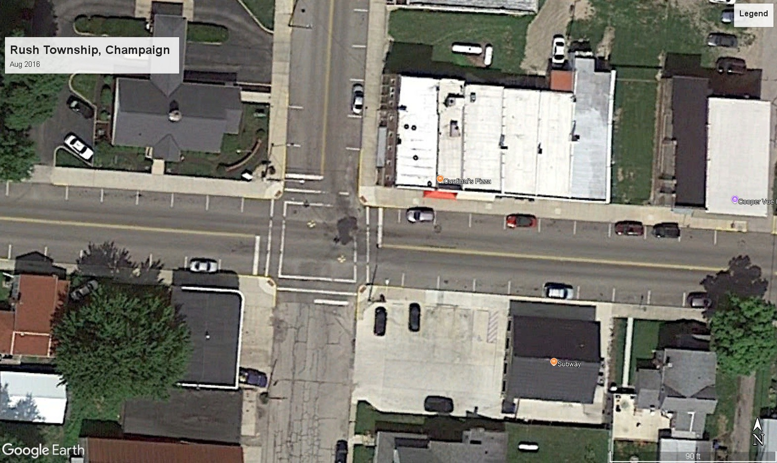
    - A Poor Quality Road
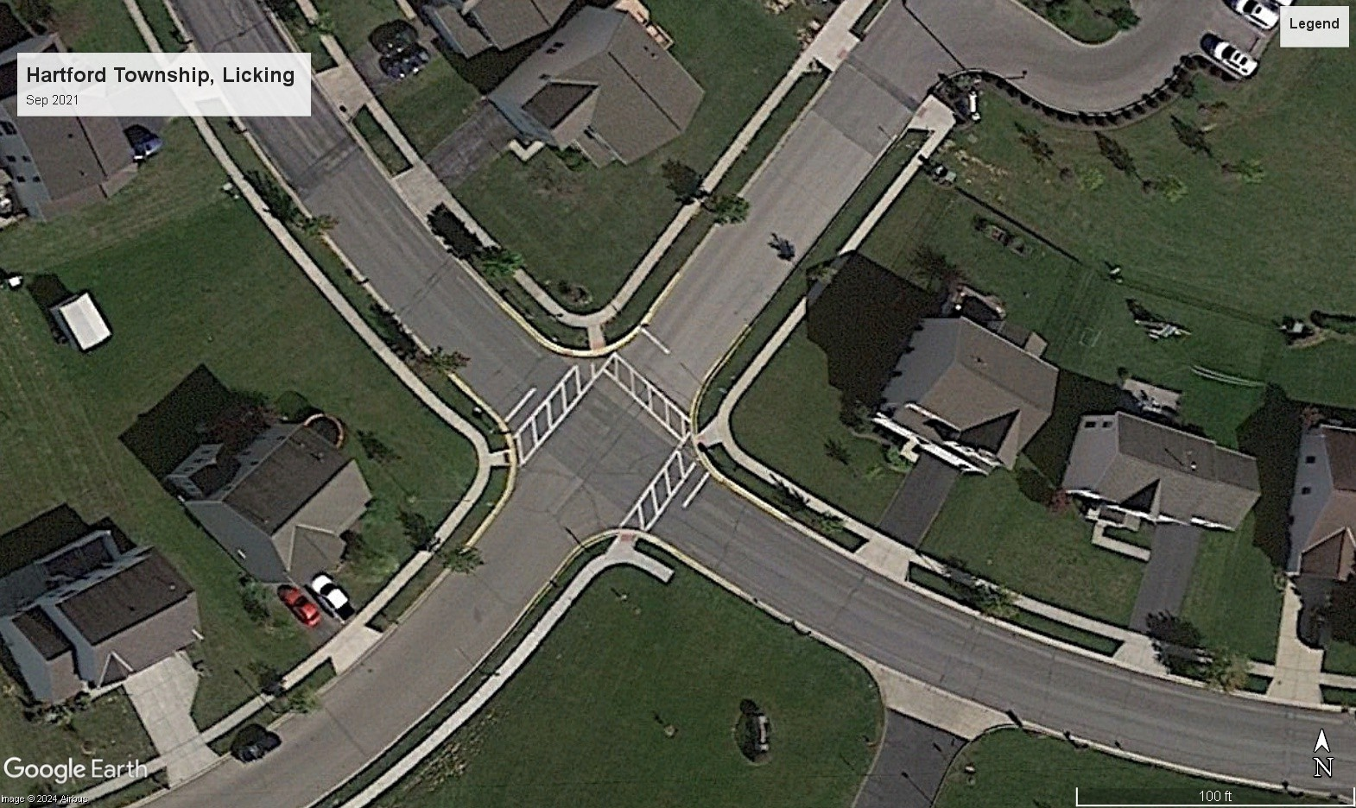
    - A High Quality Road
Figure 1: Road Quality Satellite images for Ohio

Road Quality Rating. Our fine-tuned ViT model classifies each satellite image into one of three categories: 0 (poor), 1 (average), or 2 (high). This rating is based on visual cues such
⁶This is like Gonzalez-Navarro and Quintana-Domeque (2016), which analyzes one year of pre-treatment surveys and one year of post-treatment surveys.

as pavement quality, visible cracks, patchwork, and overall surface condition, as learned by the ViT model from the labeled training data. For each image, the model outputs both the predicted class and a confidence score, which reflects the model’s certainty in its prediction. These ratings provide a standardized, objective measure of road quality across locations and time periods, enabling us to compare changes in road conditions before and after tax levy referendums for both treated and control groups.
Road Quality Score. Even though our original model output is a road quality rating⁷, we also converted the discrete model output to a continuous measure of road quality between 1 and 100. This conversion uses two variables: the predicted road quality rating and confidence score⁸, and allowed us to map our road quality rating to a number similar to Pavement Condition Rating (PCR) used by ODOT, and call this Road Quality Score (RQS). The formula for this conversion is as follows:

RQS = 1 + [(rˆ+ τ · cˆ) · w · I{rˆ ̸= 0} + (1 − τ ) · cˆ· w · I{rˆ = 0}] (2)

If this looks good in .pdf fine but the r-hat should have the hat directly over the r to look professional, same for c above where rˆ is the predicted road quality rating, cˆ is the confidence score, w is a relative weight for allotted size of each road quality rating group, 0, 1, and 2. τ is a parameter for confidence weights⁹. The RQS ranges from 1 to 100, where 0 indicates poor quality and 100 indicates high quality. We use this RQS in our analysis to assess the impact of cutting local road taxes on road quality.
Next, we share a summary of means and standard deviations of the predicted road quality rating and road quality score for the treatment and control groups, before and after the referendum.
⁷This is a direct result of our training data from Brewer et al. (2021) which uses this metric.
⁸During the prediction process, we asked the fine-tuned ViT model its confidence in the prediction i.e. the probability of the prediction being correct, a number between 0 and 1.
⁹we set this equal to 0.5.

Table 2: Predicted Road Quality by Treatment Status and Period

Treated (Failed Levy) Control (Renewed Levy)

Panel A: Road Quality Rating (0, 1, 2)

Pre-Election | 1.38 | 1.00
 | (0.770) | (0.913)
Post-Election | 0.93 | 1.07
 | (0.753) | (0.884)
Panel B: Road Quality Score (1-100)
Pre-Election | 62.1 | 47.9
 | (24.6) | (23.6)
Post-Election | 50.5 | 52.1
 | (29.3) | (28.4)
Notes: This table presents the average predicted road quality rating and score for townships before and after road tax levy elections. The control group consists of townships within the effective RD bandwidth that successfully renewed their road tax levy; whereas the treated group includes ones that failed to renew. Ratings are derived from our fine-tuned Vision Transformer model, where higher values indicate better road conditions. Scores are from equation 2. Standard deviations are reported in parentheses below the means.

Panel A of Table 2 summarizes the Road Quality Rating (RQR), showing that treated areas (failed levy) started with a higher average RQR (1.38) than control areas (1.00) before the referendum, but experienced a notable decline from 1.38 to 0.93 after the referendum, while control areas saw effectively no change and moved negligibly from 1.00 to 1.07.
Panel B of Table 2 presents the Road Quality Score (RQS), where treated areas also began with a higher average RQS (62.1) compared to control areas (47.9) before the referendum. After the referendum, RQS dropped from 62.1 to 50.5 in treated cities, whereas it increased from 47.9 to 52.1 in control cities. This pattern suggests that failing to renew a road tax levy leads to a decline in both RQR and RQS, while renewing the levy is associated with

stable or improved road quality. Section 5.1 provides a more detailed analysis of the impact of cutting road taxes on road quality, using the predictions from ViT model as the outcome variable.

Running Variable

The running variable plays a critical role in RD, which in this study represents the proportion of votes against the renewal of a road tax levy.
A vote share of more than 50 means the renewal road tax levy fails and tax will no longer be collected, resulting in a stoppage of road funding via that particular tax levy. There are 3,184 referendum results in our sample, 83% of which renew the tax, and 17% of which cut taxes and road maintenance. The Great Financial Crisis falls in the middle of our dataset, so readers might wonder if voting behavior was affected, but we find vote share the same to two decimal points during and outside the years 2008-2009.
Our key identification assumption is that the election results are not predetermined and vote share is not precisely manipulated to fall just above or below the cutoff. This assumption allows us to exploit the randomization around the cutoff and provides the variation needed to identify the causal effect of cutting road tax. We test this assumption using a density test detailed below and covariate balance tests (see Appendix B).
Density test. A classic RD assumption states that agents cannot precisely manipulate the running variable to fall just above or below the cutoff. In our context, it means that the election results are not determined prior to when the ballot takes place. In other words, no individuals, organizations, higher levels of government, foreign governments, or the firm that programs the voting machines are dictating the precise vote share for the renewal road tax levy referendums raised by a city. The standard way to test this assumption is to perform a density test like that of Cattaneo, Jansson and Ma (2020), which is based on the idea that manipulation of elections might cause a clustering of votes just to one side of the cutoff, with a pronounced drop-off on the other side of the cutoff. The p-value of this density test

is 0.98. A histogram of vote share is shown in Figure 2 that graphically illustrates the lack of abrupt change in density.
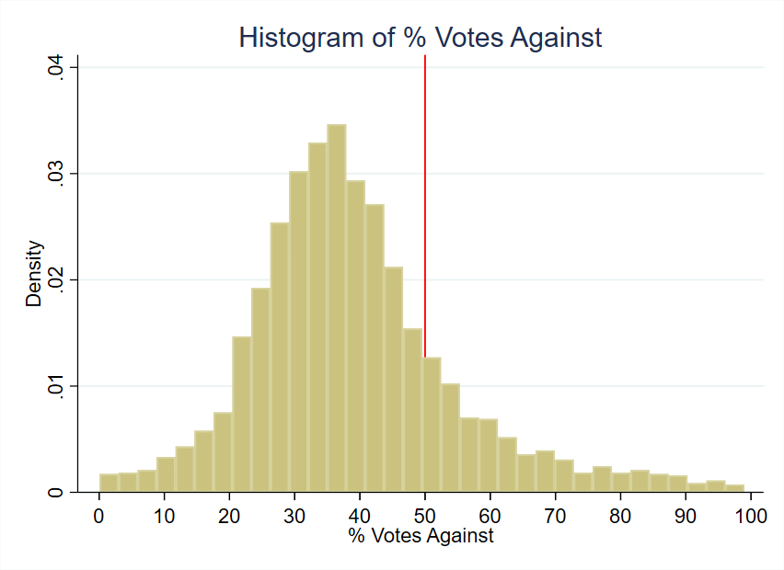
Figure 2: Histogram of Running Variable

Although Table 3 shows covariate balance between sets of cities that pass and fail to renew road tax levies, covariate values could still jump from one side of the cutoff to another. A drop in education levels, for example, could cause a drop in house prices that might coincide with a change in treatment, so that what might look like a treatment effect from cutting taxes and spending might in fact be caused by lower education levels. Graphs that suggest covariate smoothness around the cutoff are found in Appendix B. A formal way to assess covariate smoothness is to use each covariate as an outcome variable in a regression of the running variable and the treatment effect dummy. When we do so, the p-value of the treatment effect dummy varies from 0.234 to 0.981, as shown in Table 13, indicating no statistically

significant jump in covariate values.

Outcome Variable: Median House Price

Our house price data comes from a CoreLogic dataset of actual sales transaction prices in Ohio from 1995 through 2021 containing over 7 million observations. The dependent variable, Median House Price, reflects the median sale price of houses within a specific city and year, converted to constant 2010 dollars. For example, for the houses sold in Delaware Township during the year 2002, the median sale price was $205,041. We take precaution to only include arm’s-length transactions, and we restrict our attention to single-family residential structures for comparability. The overall sample mean for the 10-year period from the time of votes considered in this study is $166,082 with a standard deviation of $372,135 which suggests the presence of outliers. Although our use of median sale price addresses outliers, one of our robustness checks drops 1% tails and re-estimates the treatment effects (Figure 8).
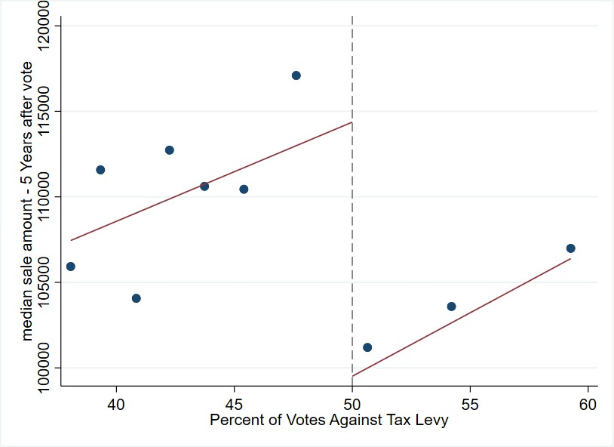
Figure 3: Median Sale Price of Houses: 5 years after vote

Figure 3 shows house prices from five years after the vote graphed alongside the percent

of votes against the tax levy¹⁰. The points represent the mean house price for the 10 repre- sentative bins of vote shares for the average effective bandwidth around the cutoff of 50%. The graph suggests a discontinuity in house prices at the cutoff, which is the basis of our identification strategy, hinting that the failure to renew a road tax levy has a negative impact on house prices.

Covariates

Covariates can be useful in RD studies, although they are not necessary for the identification of treatment effects. One use of covariates is to increase the precision of treatment effect estimates. The other is to see if cities that barely pass and fail tax levies are similar to each other like the theory of RD says they should be. Table 3 shows covariate means for both the global sample of all votes in the data set as well as the local sample within a representative effective bandwidth of the 0.50 cutoff. The effective bandwidth displayed in Table 3 is the mean bandwidth for all the housing outcome regressions. The first columns for the global sample show similar values of characteristics between cities that renew and cut road taxes and spending, but it is the two rightmost columns that are critical for the credibility of the RD design.
The data, captured at the time of the vote and as observed in Table 3, shows minimal differences within the effective bandwidth: mean population differs by only 301, and median family income varies by $436, measured in 2010 U.S. dollars. Other variables, including poverty rates, married household percentages, educational attainment, age distribution, and racial composition, show differences of two percentage point or less, bolstering the compa- rability of the treatment and control groups. This similarity suggests that any observed differences in outcomes can more confidently be attributed to the treatment effect rather than to pre-existing differences.

¹⁰after deflating to 2010 U.S. dollars

Table 3: Variable Means & Standard Deviation by Tax Levy Renewal Status

Variable |  |  | Global |  |  |  | Effective
Full Sample |  |  | Renewed | Cut |  | Renewed (Control) |  | Cut (Treatment)
Population |  | 5,072 | 4,733 | 5,139 |  | 4,885 | 5,186
 |  | (7,936) | (7,291) | (8,058) |  | (7,036) | (8,229)
Poverty Rate |  | 0.11 | 0.11 | 0.11 |  | 0.10 | 0.11
 |  | (0.08) | (0.07) | (0.08) |  | (0.07) | (0.08)
% with Kids |  | 0.39 | 0.40 | 0.39 |  | 0.39 | 0.39
 |  | (0.08) | (0.08) | (0.08) |  | (0.07) | (0.08)
% Households | with | 0.09 | 0.09 | 0.09 |  | 0.09 | 0.08
Children under 18 |  | (0.06) | (0.05) | (0.06) |  | (0.06) | (0.05)
% Less than High |  | 0.16 | 0.18 | 0.15 |  | 0.18 | 0.16
School Education |  | (0.11) | (0.12) | (0.11) |  | (0.12) | (0.10)
% Some College Edu- |  | 0.25 | 0.24 | 0.25 |  | 0.24 | 0.25
cation |  | (0.06) | (0.06) | (0.06) |  | (0.07) | (0.06)
% Renters |  | 0.20 | 0.20 | 0.20 |  | 0.19 | 0.20
 |  | (0.11) | (0.10) | (0.11) |  | (0.09) | (0.11)
Unemployment Rate |  | 0.05 | 0.05 | 0.05 |  | 0.05 | 0.06
 |  | (0.04) | (0.03) | (0.04) |  | (0.03) | (0.04)
% White |  | 0.96 | 0.97 | 0.96 |  | 0.97 | 0.97
 |  | (0.07) | (0.07) | (0.07) |  | (0.07) | (0.08)
% Black |  | 0.02 | 0.02 | 0.02 |  | 0.02 | 0.02
 |  | (0.07) | (0.06) | (0.07) |  | (0.07) | (0.07)
% Married |  | 0.59 | 0.60 | 0.59 |  | 0.61 | 0.60
 |  | (0.09) | (0.08) | (0.09) |  | (0.08) | (0.09)
% Separated |  | 0.01 | 0.01 | 0.01 |  | 0.01 | 0.01
 |  |  |  |  |  |  | Continued on next page

Table 3 – continued from previous page

Variable Global Effective

Full Sample | Renewed | Cut | Renewed (Control) | Cut (Treatment)
(0.01) | (0.01) | (0.01) | (0.01) | (0.01)
Income Heterogeneity 0.10 | 0.09 | 0.10 | 0.09 | 0.09
Index (0.08) | (0.07) | (0.08) | (0.07) | (0.06)
Median Family In- 61,018 | 58,761 | 61,467 | 59,934 | 60,370
come (17,649) | (13,915) | (18,270) | (13,655) | (15,713)
% Under 5 Years Old 0.06 | 0.06 | 0.06 | 0.06 | 0.06
(0.02) | (0.02) | (0.02) | (0.02) | (0.02)
% Aged 5 to 17 0.20 | 0.21 | 0.20 | 0.20 | 0.20
(0.05) | (0.04) | (0.05) | (0.04) | (0.05)
% Aged 18 to 64 0.60 | 0.60 | 0.60 | 0.60 | 0.60
(0.05) | (0.05) | (0.05) | (0.04) | (0.05)
% Racial Minority 0.04 | 0.03 | 0.04 | 0.03 | 0.03
(0.07) | (0.07) | (0.07) | (0.08) | (0.07)
Number of Observa- 3,184 | 2,656 | 528 | 653 | 269
tions

Empirical Strategy

In this section, we describe our empirical strategy to estimate the causal effect of cutting road maintenance spending on house prices. One key feature of our quasi-experiment design is the exogeneity of the timing of the election. The timing is determined by the natural expiration of a road maintenance tax levy, which is typically 5 years, and is not impacted by factors such as the prevailing economic conditions or whether a road tax levy was passed or failed in earlier years.

Regression Discontinuity in Panel Data setting

Suppose that local government in area i and year t conducts a referendum to renew an existing road tax levy. Let v_{it} be the vote share against the renewal tax levy and v∗ be the threshold determining the result of the referendum (levy fails to renew if v_{it} > v∗). Let F_{it} = 1(v_{it} > v∗) be an indicator to represent if the renewal road tax levy fails, and y_{it} be the outcome variable median housing sale price. We can write Equation 3 as follows:

y_{it} = α + θF_{it} + ϵ_{it} (3)

where α is the intercept, θ is the parameter of interest representing the causal effect of renewing a road tax levy and ϵ_{it} is the error term representing all other determinants of the outcome. Around a narrow enough window around the threshold v∗, we can estimate the causal effect of renewing a road tax levy on the outcome variable y_{it} by comparing the outcome variable for cities that narrowly pass the referendum to those that narrowly fail it.

Intent-to-Treat (ITT) Estimator

We follow a model of RD design similar to Cellini, Ferreira and Rothstein (2010) and estimate the Intent-to-Treat or ITT estimator. We prefer using the ITT estimator instead of the alternative Treatment on the Treated (TOT) estimator because the ITT estimator is more suited to our setting given the independence of the renewal elections. As described in Cellini, Ferreira and Rothstein (2010), when the elections are independent, the ITT estimator equals the TOT estimator.
We operationalize our ITT estimator using Equation 4:

Yi,t+τ = ατ + κt + FitθIT T + Pg (vit, γτ ) + Zitβτ + ϵi,t+τ (4) Equation 4 shows a city i that holds an election in year t and we study this city’s outcome
τ
τ years later. Y_{i,t+τ} represents the outcome variable for city i at year t + τ . We define

treatment as failure of a city, village or township to renew its road maintenance tax levy, which is represented by the indicator F_{it}, and θ^{ITT} is the causal effect of failing to renew road tax on the outcome. P_{g}(v_{it}, γ_{τ} ) is a polynomial function of the running variable v_{it}, which is the percent of votes against the renewal tax levy. α_{τ} and κ_{t} represent timing and year- specific fixed effects. Z_{it} is a vector of control variables that include city-level demographics, economic conditions, and other relevant covariates. ϵ_{i,t+τ} is the error term.
τ
We use the bandwidth selection method of Calonico et al. (2019) to find the mean opti- mal bandwidth h and then conduct a local polynomial regression after choosing a weighting scheme k. The bandwidth h determines the size of the neighborhood around the cutoff v∗, defined as (v∗ −h, v∗ + h). Only observations within this neighborhood are used to compute the bias-corrected treatment effect estimate τˆ. For a sufficiently small neighborhood, the continuity assumption central to the RD estimator is considered valid. We also cluster the standard errors by city to account for any serial correlation between years within each city. The weighting scheme k determines the weights of the observations within the neighborhood (v∗ −h, v∗ + h) and is crucial in estimating θ_{τ} . Common weighting schemes include uniform, triangular, and Epanechnikov. We use the default Mean Squared Error Regression Discon- tinuity (MSERD) method to compute the effective bandwidth (h) and bias bandwidth (b) for the outcome variable. This method identifies the bandwidth that minimizes the trade-off between bias and variance of the treatment effect estimate. All observations are used to estimate h and b, but only those within the effective bandwidth h are used to identify our treatment effect estimates θ_{τ} for different τ years.

Results

Road Quality Decline

While Table 2 shows raw changes in AI-scored road quality before and after votes, we now explore the change in road quality using regression analysis. As discussed in Section 3.3, we use a fine-tuned Vision Transformer

(ViT) model to assess road quality based on satellite imagery data. The model gives us a road quality rating of 0 (poor), 1 (medium), or 2 (high), which we further convert to a continuous variable called Road Quality Score (RQS) ranging from 1 to 100. We restrict our sample to the optimal RD bandwidth from our baseline analysis (that we will discuss in Table 5) and regress the 0, 1, 2 Road Quality Rating as a function of a levy passage dummy. We do this for the set of cities that vote to cut funding, and we repeat the analysis for the set of cities that vote to renew funding. The estimates of the levy passage dummy are shown in the first row of results in Table 4 below. We repeat the analysis for the 1 - 100 Road Quality Score and show the results in the second row of Table 4.
Table 4: Effect of Road Maintenance Tax Levy Results on Road Quality

 | Cut Levies | Renewed Levies
Panel A:  Change in 0, 1, 2 Road Quality Rating | -0.444** | 0.067
 | (0.210) | (0.340)
Panel B:  Change in 1 - 100 Road Quality Score | -14.231** | 1.585
 | (6.651) | (10.926)
Notes: Each column represents an estimate of change in road quality from regressions for the set of cities that cut and renewed their road tax levies. Panel A reports results using the categorical road quality rating (0 = poor, 1 = medium, 2 = high). Panel B reports results using the continuous Road Quality Score (RQS, 1–100 scale). Samples are the set of referendums within the mean effective RD bandwidth from Table
5. “Cut Levies” refers to jurisdictions that failed to renew their road tax levies, while “Renewed Levies” refers to jurisdictions that renewed. Standard errors are shown in parentheses.
Significance levels: *p < 0.10, **p < 0.05, ***p < 0.01.

For cities that fail to renew their road tax levies, there is a statistically significant

decline in road quality: a reduction of 0.444 points on the categorical scale and 14.23 points on the RQS. The 0.444 decline in quality on a mean of 1.38 translates to a 32% deterioration in road quality, and the 14.23 point decline on a mean of 62.1 translates to a 23% decline for the RQS measure of quality. In contrast, cities that renew their levies show no significant change in either measure of road quality. These results indicate that cutting road maintenance taxes leads to a meaningful deterioration in road quality, while maintaining taxes helps preserve it. This finding underscores the tangible infrastructure consequences of fiscal policy decisions and reinforces the broader argument of the paper regarding the importance of stable funding for public goods.

House Prices Decline

Table 5 below shows the ITT estimates of failing a road tax levy on housing sale prices. Appendix A.1 shows the full set of results, while Table 5 below restricts its attention to estimates starting four years after the vote, the first year statistical significance is found.
Each treatment effect estimate represents the discount in median sale price for cities that cut road taxes in the years after voting on a road tax levy relative to otherwise similar cities that renew the taxes. Treatment effect estimates for years 4 through 9 after the vote are statistically significant with p-values below the canonical 0.05 threshold. The estimate for year t + 10 has a smaller estimate and is only significant at the 10% level, suggesting that the effect of tax and service cuts on house prices may peter out ten years after the vote. Overall, we find an average reduction of $15,349 not true: it's 19,309 using t+4 through t+10 in median house price over the 10-year period for houses in cities that vote to cut road tax levies, representing 9% of overall house value¹¹. The 9% reduction we estimate may be comparable to Gonzalez-Navarro and Quintana-Domeque (2016) who observe a change in property values of 17-28% after a new pavement, or Theisen and Emblem (2021) who find a 13% house price increase after roads paving¹².
¹¹The average treatment effect estimate of $15,349 was divided by the mean house sale price in the dataset
of $166,000 to get 9%.
¹²Note that these studies focus on the effect of developing paved roads whereas we focus on deterioration of existing paved roads.

Table 5: Effect on median house prices of failing to renew a road tax levy

Year rela-  tive to vote | t + 4 | t + 5 | t + 6 | t + 7 | t + 8 | t + 9 | t + 10
Treatment | -21,638 | -22,271 | -17,336 | -15,975 | -21,993 | -19,857 | -16,090
effect
Standard | (7,731) | (8,864) | (8,331) | (7,248) | (9,079) | (7,751) | (9,027)
error
Effective | 8.540 | 10.796 | 9.840 | 13.158 | 8.246 | 7.285 | 6.241
bandwidth
(h)
Bias band- | 16.379 | 19.879 | 17.397 | 23.413 | 15.255 | 14.091 | 16.266
width (b)
Effective | 688 | 883 | 769 | 1,061 | 591 | 505 | 402
Observa-
tions
Total Ob- | 2,614 | 2,531 | 2,438 | 2,324 | 2,199 | 2,115 | 2,017
servations
Notes: Outcome is median house price in constant 2010 U.S. dollars. Unit of observation is the city-year, so a treatment effect of -$21,638 means that four years after the vote, cities that fail to renew road taxes and their associated spending have houses that sell for $21,638 less than cities that vote to renew road taxes and spending. Treatment effects for years prior to t + 4 are statistically insignificant at the 5% level; full results shown in Table 10. The regressions include covariates related to the demographics and socioeconomic factors of the cities, drawn from Table 3.

Figure 4 provides an event-study plot that summarizes the treatment effects for each time period. In the graph, we include placebo years up to 3 years before the treatment to show that the median housing prices are statistically identical for cities above and below the threshold prior to the treatment. Each dot represents the treatment effect point estimate for that year and the bar around it represents the 95% confidence interval for that estimate. For year 0, which is the year of the vote, we see a slight decrease in the estimate. However, this effect is not statistically significant, as evidenced by the confidence interval containing the null effect. Up to year 3, we observe that the treatment effect estimates are fairly close to zero, and the confidence interval overlaps with zero. As stated previously and shown in Table 5, we start to see a sizable increase in treatment effect from year 4 onwards and continue to observe it through year 9 after the vote.

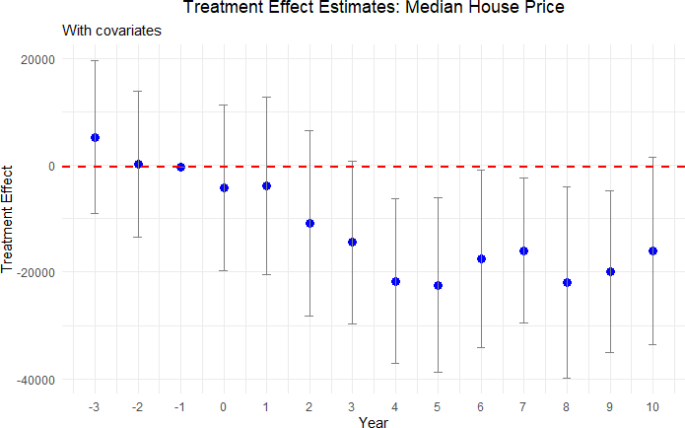

Figure 4: Effect plot for Median Housing Price

Heterogeneity Analysis

We show the results of our heterogeneity analysis, where we explore the differential impact of cutting road maintenance spending on house prices in urban and rural neighborhoods, the size of the tax levy and housing price quantiles.

Urban vs Rural neighborhoods: We first compare treatment effects in urban and rural areas. We consider two different ways to define a city as urban: one including only urbanized areas and another one including both urban areas and urbanized clusters.
As shown by Figure 5, we do not find any significant differences in housing prices in rural areas after a renewal tax levy fails to pass. On the other hand, we do find a statistically significant decline in housing prices in urban areas starting six years after voting. The standard errors are somewhat smaller for the rural estimates due to a larger number of observations. The difference in point estimates between urban and rural areas may stem

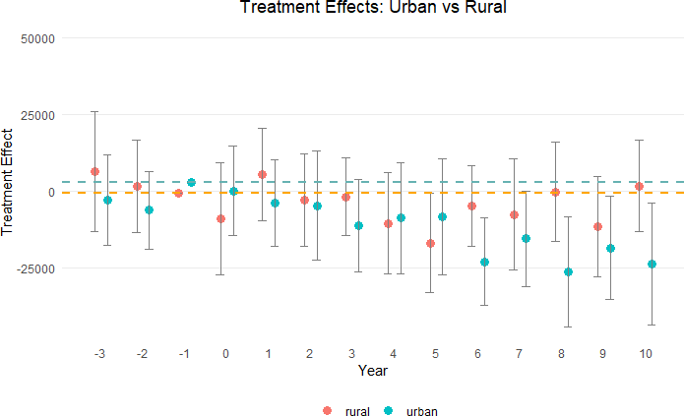

Figure 5: Median Housing Price in Urban and Rural Areas

from differences in housing supply elasticity (Brasington, 2002). Overall, we find that housing prices decrease by $13,302 on average over the decade¹³ after cutting road maintenance tax levies in urban areas.

Tax magnitude: We check for dose-response by splitting the sample and focusing only on impact of cuts in road maintenance tax levies based on levy size. First, we consider splitting the sample based on the median size of the tax levies, which is 1.9 mills. We find no significant differences in treatment effects this way. Next, we focus on large tax cuts--the top quartile--defined as any tax cut greater than 2 mills, ranging from 2.1 to 8 mills. Figure 6 below presents the results for this
13This is equal to 7.6% = ^{13,302} × 100, where the denominator is average sale price of houses in urban
175,217
areas in our dataset.

subsample. The treatment effect estimates for these larger tax cuts are both statistically significant and of greater magnitude, indicating a more pronounced decline in house prices when the reduction in road tax levies is more substantial.
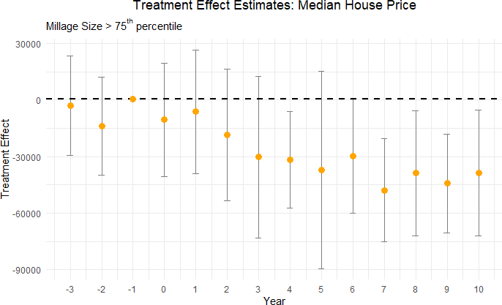

Figure 6: Effect of Large Road Maintenance Tax Cuts (>2 mills) on Median House Price

Despite the reduction in sample size leading to wider standard errors in Figure 6, the overall pattern in decline of house price remains, with mean treatment effect for this sub- sample being approximately $30,000 which is about double the effect observed in the full sample. Maybe not double if 15,000 was wrong number This finding supports the presence of an intensive margin effect: the larger the tax cut, the greater the negative impact on housing prices. Such a pattern is consistent with a dose-response relationship, where the magnitude of the fiscal shock translates directly into the size of the decline in property values.

RDD Quantile Estimation: We further analyze our results by estimating quantile- level treatment effects, as suggested by Frandsen, Fr¨olich and Melly (2012), to study how

the treatment’s impact varies at different quantiles of the outcome variable.

Table 6: Quantile-level Treatment Effects of Cutting Road Spending on Median House Prices
Percentile | t + 4 | t + 5 | t + 6 | t + 7 | t + 8 | t + 9 | t + 10
10% | -6,433 | -22,570 | -9,602 | -12,984 | -11,217 | -6,569 | -1,326
 | (9,364) | (9,065) | (9,205) | (8,420) | (9,136) | (10,809) | (8,793)
20% | -5,400 | -15,070 | 4,014 | -14,682 | -15,040 | -3,228 | 624
 | (9,983) | (9,886) | (7,443) | (8,502) | (8,160) | (10,435) | (8,509)
70% | -21,760 | -11,171 | -38,082 | -36,685 | -21,356 | -25,605 | -18,600
 | (12,333) | (11,806) | (12,835) | (12,163) | (12,218) | (13,984) | (9,872)
80% | -28,478 | -16,379 | -38,460 | -37,470 | -28,950 | -27,800 | -18,658
 | (13,343) | (11,404) | (18,623) | (12,169) | (12,507) | (12,421) | (11,808)
90% | -51,470 | -34,604 | -38,510 | -27,039 | -29,010 | -49,093 | -36,662
 | (18,409) | (15,837) | (22,194) | (16,308) | (16,640) | (14,498) | (19,110)
Notes: The outcome is median house price in constant 2010 U.S. dollars. The unit of observation is the city-year, so a treatment effect of -$28,478 means that at the 80th percentile of house prices four years after the vote, cities that fail to renew road taxes and the associated spending have houses that sell for $28,478 less than cities that vote to renew road taxes and spending. The regressions include covariates related to the demographics and socioeconomic factors of the cities, drawn from Table 3.

Table 6 shows the treatment effect heterogeneity of cutting road spending on high and low quantiles of median house prices. The top percentiles consistently exhibit a statistically significant decline in house sale prices, beginning in year 6 after the reduction in road spend- ing. In contrast, the lower percentiles do not demonstrate a consistent treatment effect. This suggests a differential impact, where higher-valued properties are more sensitive to road dis- repair than lower-valued houses. Figure 7 contrasts the treatment effects of the 20th and 80th percentiles of house sale prices in an effect plot to highlight this differential impact of reduction in road maintenance spending.

Robustness Tests

We conduct several robustness tests to ensure the validity of our results. We test the sensi- tivity of our results to different bandwidths, covariates, and functional forms. We also check for the presence of pre-trends and perform a placebo test to confirm the validity of our RD.

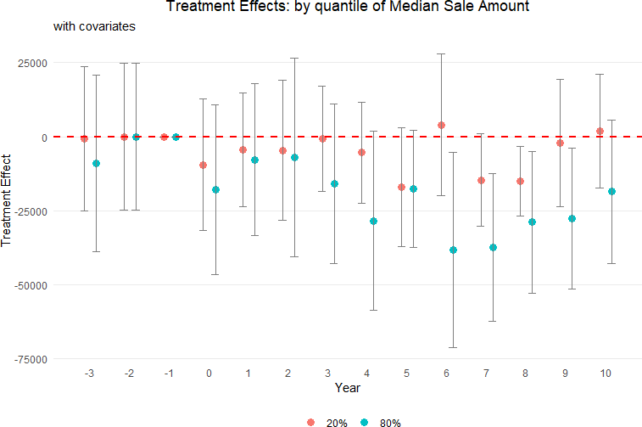

Figure 7: Treatment Effect of Cutting Road Maintenance Taxes for 20th and 80th Percentiles of Median House Price

Removing contradictory observations: In this test, we focus on independence and exogeneity. Estimates may be biased if tax levies for additional money pass after renewal tax levy decisions. To address this concern, we exclude observations from our analysis if a tax levy for additional funding is introduced and passed within a ten-year period following a renewal tax levy vote. For example, consider a scenario where a city votes on a renewal tax levy in the year 2000. If that city subsequently introduces and passes a tax levy for additional road spending in 2004, we exclude all votes for that city from 2005 through 2010. This exclusion ensures that the effect on house prices from the 2000 vote are captured for uncontaminated years but not for years after 2004 when the effect of additional road taxes may counteract the drop in tax money from the year 2000 vote.
Table 7: Effect on Median Sale Amount of Failing to Renew a Road Tax Levy

year relative to  vote | t + 4 | t + 5 | t + 6 | t + 7 | t + 8 | t + 9 | t + 10
Treatment | -19,015 | -15,609 | -18,403 | -20,842 | -18,950 | -28,634 | -23,823
effect
standard error | (9,563) | (10,283) | (10,246) | (9,629) | (9,179) | (7,770) | (10,594)
Effective band- | 6.88 | 5.92 | 8.36 | 9.42 | 7.91 | 5.43 | 7.05
width (h)
Bias bandwidth | 12.14 | 15.94 | 14.53 | 17.87 | 15.24 | 11.90 | 17.33
(b)
Effective Ob- | 475 | 389 | 561 | 611 | 475 | 300 | 374
servations
Total Observa- | 2,389 | 2,274 | 2,145 | 2,016 | 1,890 | 1,787 | 1,666
tions
Notes: The outcome is median house price in constant 2010 U.S. dollars. The unit of observation is the city-year, so a treatment effect of -$19,015 means that four years after the vote, cities that fail to renew road taxes and its associated spending have houses that sell for $19,015 less than cities that vote to renew road taxes and spending. The regressions include covariates related to the demographics and socioeconomic factors of the cities, drawn from Table 3.

Upon implementing this data filtration, we observe that the treatment effect of the re- newal levies on housing prices, measured from t + 1 to t + 10, remains largely consistent with our initial findings. This consistency in treatment effect, despite the exclusion of potentially confounding data, lends further credence to our results. The standard errors increase slightly

due to the reduction in sample size caused by the aforementioned data filtration process.
Placebo cutoffs: In our primary analysis, the pivotal threshold for the vote share running variable is 50%, indicating whether a renewal levy passes or fails. Although we find significant treatment effects using this 50% threshold, it could be random jumps in the data rather than cutting road taxes and funding that are responsible for the significant estimates. To this end we conduct a series of placebo tests using alternative cutoffs: 30%, 40%, 60%, and 70%. Table 8 below summarizes the results from the placebo cutoffs analysis.
Table 8: Robust Treatment Effect Estimate for Placebo Cutoffs

Years after | 30% | 40% | 60% | 70%
vote
t + 4 | 2,578 | 9,149 | 9,419 | -12,987
 | (8,209) | (7,284) | (11,462) | (14,365)
t + 5 | -6,381 | -29,077 | 6,383 | 41,683
 | (9,086) | (20,680) | (10,786) | (17,836)
t + 6 | 7,681 | 5,573 | -1,095 | -14,226
 | (9,616) | (8,120) | (8,612) | (15,733)
t + 7 | 1,162 | 3,982 | -12,050 | 22,261
 | (10,468) | (8,191) | (9,396) | (19,765)
t + 8 | 4,334 | 12,881 | 3,593 | 31,696
 | (9,670) | (8,625) | (10,061) | (6,902)
t + 9 | 851 | 7,381 | -6,935 | 42,790
 | (5,921) | (6,333) | (7,114) | (15,663)
t + 10 | 10,032 | -35,038 | 324 | -8,566
 | (10,599) | (35,569) | (8,220) | (17,281)
Notes: Robust treatment effect estimate for placebo cutoffs as per the estimator from Calonico et al. (2017). The unit of observation is city-year level. Standard errors are shown in parentheses below each estimate.

Table 8 does not show consistently significant treatment effects for any of the placebo cutoffs for our parameter of interest. This absence of significance at thresholds other than the true 50% reinforces the idea that the effects we observe at the 50% mark are not a mere coincidence or a result of random variation in the data, but are indeed attributable to the dynamics surrounding the passing or failing of renewal tax levies.
Winsorization: The debate over whether to include or exclude outliers continues, with some research suggesting that trimming outliers does not improve mean squared er-

ror (Bollinger and Chandra, 2005). We now drop the 1% tails to help curtail the influence of outliers. The overall sample mean after dropping 1% tails is $150,505 in constant 2010 dollars with a standard deviation of $115,646. After performing this winsorization step, we re-estimate the treatment effect of failing to renew a road tax levy on housing outcome variables. The results from this estimation process are summarized in Figure 8 below:
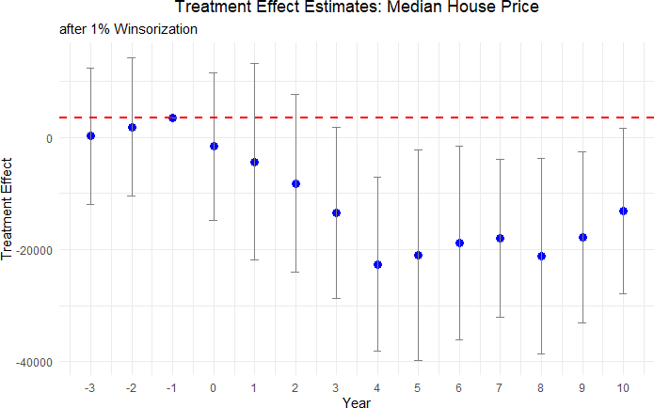

Figure 8: Effect of Cutting Road Maintenance Taxes on Median Housing Price after 1% Winsorization

The treatment effect estimates with winsorization mimic those from our baseline regres- sion results qualitatively and quantitatively.
Other Tax Levies: A potential threat to identification is that a cut in road tax levy might be correlated with cuts in other local tax levies, or may simply reveal an underlying, time-varying taste for lower taxes or smaller government. If the same electorate simulta- neously rejects (or approves) levies for police, fire, recreation, or schools, our estimated road-maintenance effect could in fact be picking up broader changes in local public-service

bundles that are themselves capitalized into housing prices--but only if there is an imbalance between the sets of cities that barely pass and fail road tax renewal levies. To address this concern, we examine whether the outcome of a renewal road levy is systematically correlated with the outcomes of other levy referenda held on the same ballot or within the same fiscal year i.e. whenever a road tax levy is cut, are there elections and subsequent tax cuts for other tax levies as well.
Table 9: Association of Road Tax Levy Referenda Results with Other Types of Levies

Police | Fire | Recreational | School
Estimate 0.248 | 0.053 | 0.015 | -0.024
(0.153) | (0.043) | (0.317) | (0.092)
Notes: This table presents coefficients from regressions associating road tax levy referendum outcomes with outcomes for other types of levies (police, fire, recreational, school). Standard errors are reported in parentheses. All regression control for year and neighborhood fixed effects, as well as neighborhood characteristics. The school levy analysis is conducted at the county level, while all other analyses are at the county subdivisions level. Statistical significance levels are indicated as follows: *** p < 0.01, ** p < 0.05,
* p < 0.1.

Table 9 reports coefficients from separate regressions in which each column regresses the pass/fail outcome of another levy type on the road-levy outcome, controlling for year fixed effects, jurisdiction fixed effects, and demographic covariates. For county-level school levies we cluster to the county, while all other specifications are at the township/city (“county subdivision”) level. The point estimates are small and statistically indistinguishable from zero: a failed road-maintenance renewal is neither more nor less likely to coincide with the failure of levies earmarked for police, fire, recreation, or schools. For example, the largest coefficient, 0.248 for police levies, has a standard error of 0.153 and is not significant even at the 10 percent level. These results suggest that voters treat the road-maintenance question separately from other local tax questions, and that decisions to cut or renew road funding are not simply proxies for a general anti-tax or austerity sentiment. Consequently, our main RD estimates are unlikely to be confounded by contemporaneous changes in other public services.
A more comprehensive approach to address this concern is to check for balance in all tax levies around the cutoff. As the theory of regression discontinuity suggests, cities close to

the 50% vote cutoff are as good as randomized along the cutoff. If true, there should be no difference in funding changes from other tax levies between the pass-levy and fail-levy groups. To confirm this, we collect all 40,000 local tax levies for all municipal purposes from 1991 to 2021, including current expense tax levies, parks and recreation, and police funding, for example. We identify the tax levies for the cities within the effective bandwidth and compare the proportion of cities that renew and fail to renew road tax levies that have other tax levies on the ballot for different purposes at the same time as the road tax levy. The pass-levy group has only a road tax levy on the ballot 48.1% of the time, and the fail-levy group only a road tax levy on the ballot 47.96% of the time. The two groups are balanced, as suggested by RD theory.
Next, we take a deeper look at the 52% of cities within our effective bandwidth with non-road tax levies on the ballot. The cities that barely vote to renew road taxes experience a change in other taxes, either an increase in new spending or a cut in existing spending, 12% of the time. The corresponding figure for the set of cities that barely votes to cut road taxes is 15%. We suggest that 12% and 15% are small numbers to begin with, and we further suggest that these numbers are similar. Randomization near the cutoff suggests that both observable and unobservable characteristics are balanced between pass and fail road tax levy groups, and this is what we find in our sample. Thus, the difference in house prices can best be attributed to tax cuts in road maintenance funding and decreases in road quality.

Mechanisms

A key question surrounding our findings is why cutting road taxes would lead to a sustained decline in local house prices. In this section, we argue that these results are consistent with classical insights from the literature on local public finance, especially the work of Oates (1972) and Edel and Sclar (1974). Specifically, cutting road-maintenance tax levies reduces local government funds for maintaining infrastructure, which in turn constrains the government’s ability to provide road-upkeep services. These lower levels of maintenance funding result in a deterioration of road quality, which then directly and indirectly lowers

housing values. We trace this relationship through three sequential links.
- Road Tax Cuts and Reduced Road Maintenance Funds. Local governments in Ohio, like those in many other U.S. states, rely on property taxes and dedicated road levies to fund local public goods. Oates (1972) decentralization theorem highlights that local authorities can generally provide public services in a manner better aligned with resident preferences than would a higher-level government, provided they have adequate revenue sources. When a renewal levy fails at the ballot box, one of these critical revenue sources vanishes. Consistent with the premise that local road quality is a local public good, losing a dedicated revenue stream substantially weakens a city’s ability to maintain or upgrade roads. Empirically, we infer the size of the drop in maintenance funds when a maintenance levy fails to renew in Table 1.
- Decline in Road Quality. Once the road tax levy is not renewed and the budget is cut, the local government has fewer resources to maintain roads, but is reduced maintenance reflected in the quality of roads? We study this question and explain our method to measure road quality in Section 3.3. Results from our AI model-based road-quality measures in Section 5.1 show a marked decrease in road quality following the cut of renewal road tax levies. The resulting deterioration in road quality is primarily seen through remote sensing data, but may be experienced via ride discomfort, declining aesthetics, and reduced usability of neighborhood roads. This is precisely what a local public goods framework would predict: fewer financial resources for upkeep immediately impact the quality of local public good. Residents observe these changes slowly over time, often after four to five years, before road conditions become visibly poor.
- Capitalization into House Prices. Falling road quality imposes a disamenity on local residents via reduced local infrastructure that is capitalized into house values (Oates, 1969). A couple of mechanisms help explain the ultimate discount in property values:
Appearance and Neighborhood Appeal. Rough roads, potholes, and poorly patched surfaces reduce aesthetic appeal of the homes in a neighborhood. Poten-

tial buyers, seeing visible signs of neglect, bid less, therby reducing the sale price of homes.
Travel Costs. Lower quality roads and chronic maintenance issues translate into slower commute times for residents, particularly in urban areas. This is a direct disu- tility for homeowners, as time lost in traffic takes time away from leisure or work.
Short-Run versus Long-Run Trade-Off. Importantly, a trade-off emerges over time. In the short run, residents in cities that voted against a road tax levy experience immediate relief in terms of lower property tax bills¹⁴. Their out-of-pocket expenses decline, which can be a tangible financial benefit—particularly in communities where property tax burdens were already viewed as high. However, as road quality starts to visibly deteriorate from around the fourth year onward (see Table 5), the same residents find themselves negatively affected by a decline in house prices. This lag reflects the time it takes for infrastructure disrepair to become apparent, be it through more frequent potholes or visibly eroding surfaces. By the time these problems are evident, the city’s real-estate market has had sufficient time to register the disamenity, capitalizing it as a discount in property values. This dynamic captures a fundamental insight of local public finance: the preferences of current taxpayers can diverge from the longer-term public interest (Buchanan and Tullock, 1962; Alesina and Tabellini, 1990).

Conclusion

Most studies look at the impact of new infrastructure on housing values in developing nations (Asher and Novosad, 2020; Huang, 2016; Li et al., 2016). Recent studies recognize the difficulties in providing unbiased estimates and account for the fact that the decision on where to place new capital infrastructure is an endogenous decision and may be correlated with other factors (Biasi, Lafortune and Sch¨onholzer, 2025; Baum-Snow, 2007; Donaldson and ¹⁴Table 1 reflects the relief in property tax payments for households when a road tax levy is not renewed.

Hornbeck, 2016). We avoid this identification issue by studying maintenance spending on existing infrastructure. This focus is particularly important in developed economies, where the construction of new infrastructure is infrequent compared to the large stock of existing assets and as a consequence, maintaining and preserving existing infrastructure becomes a central focus for policymakers.
By constructing a novel panel of over 3,000 renewal referendums, matching election results to local financial records and CoreLogic house-sale data, and fine-tuning a Vision Transformer model on satellite imagery, we trace the full chain of events from a failed levy to deterioration in road quality and, ultimately, to decline in property values. Our reduced-form estimates reveal that failing to renew a road-maintenance levy leads to an average funding loss of 11% for local road budgets, a 23% decline in a continuous road-quality score derived from remote sensing, and a 9% decrease in median house sale prices. The effect on home values emerges only after year four and persists through at least year nine, underscoring the gradual yet lasting consequences of underfunded maintenance. Heterogeneity analyses show that urban jurisdictions experience larger price declines than rural ones, and high-value homes are more sensitive to road-quality shocks than lower-value homes. We also find evidence of a dose- response relationship, where larger levies lead to greater declines in house prices.
Our findings speak directly to the literature on infrastructure-economics and hedonic-pricing by demonstrating how tax cuts that reduce local governments’ ability to maintain roads can lead to a decline in road quality, which is then capitalized into local housing markets. From a policy perspective, our results highlight the importance of stable maintenance budget streams for local governments and considering proactive preservation strategies, especially in urban areas where property stakes are high.
Future work could extend our dynamic RD framework to other states or countries, inves- tigate the effects of funding via other types of tax levies, and explore complementarities between road maintenance and other forms of public investments. Advances in AI, such as Vision Transformers, open new avenues for researchers and could potentially allow real-time

evaluation of road quality, and possibly enable assessment of infrastructure policies and their welfare consequences.

References
Achiam, Josh, Steven Adler, Sandhini Agarwal, Lama Ahmad, Ilge Akkaya, Flo- rencia Leoni Aleman, Diogo Almeida, Janko Altenschmidt, Sam Altman, Shya- mal Anadkat, et al. 2023. “Gpt-4 technical report.” arXiv preprint arXiv:2303.08774.
Alesina, Alberto, and Guido Tabellini. 1990. “A Positive Theory of Fiscal Deficits and Government Debt.” Review of Economic Studies, 57(3): 403–414.
Asher, Sam, and Paul Novosad. 2020. “Rural roads and local economic development.”
American Economic Review, 110(3): 797–823.
Baum-Snow, Nathaniel. 2007. “Did highways cause suburbanization?” The quarterly journal of economics, 122(2): 775–805.
Beenstock, Michael, Daniel Feldman, and Daniel Felsenstein. 2016. “Hedonic pricing when housing is endogenous: The value of access to the trans-Israel highway.” Journal of Regional Science, 56(1): 134–155.
Biasi, Barbara, Julien Lafortune, and David Sch¨onholzer. 2025. “What Works and for Whom? Effectiveness and Efficiency of School Capital Investments Across the U.S.*.” The Quarterly Journal of Eco- nomics, qjaf013. eprint: https://academic.oup.com/qje/advance-article- pdf/doi/10.1093/qje/qjaf013/61946414/qjaf013.pdf.
Boesen, Ulrik. 2021. “How Are Your State’s Roads Funded?” Accessed: 2025-01-23.
Bollinger, Christopher R, and Amitabh Chandra. 2005. “Iatrogenic specification er- ror: A cautionary tale of cleaning data.” Journal of Labor Economics, 23(2): 235–257.
Brasington, David M. 2002. “Edge versus center: finding common ground in the capital- ization debate.” Journal of Urban Economics, 52(3): 524–541.
Brasington, David M. 2017. “School spending and new construction.” Regional Science and Urban Economics, 63: 76–84.
Brewer, Ethan, Jason Lin, Peter Kemper, John Hennin, and Dan Runfola. 2021. “Predicting road quality using high resolution satellite imagery: A transfer learning ap- proach.” Plos one, 16(7): e0253370.
Buchanan, James M., and Gordon Tullock. 1962. The Calculus of Consent: Logical Foundations of Constitutional Democracy. Ann Arbor:University of Michigan Press.
Calonico, Sebastian, Matias D Cattaneo, Max H Farrell, and Roc´ıo Titiunik. 2017. “rdrobust: Software for regression-discontinuity designs.” The Stata Journal, 17(2): 372– 404.
Calonico, Sebastian, Matias D Cattaneo, Max H Farrell, and Roc´ıo Titiunik. 2019. “Regression discontinuity designs using covariates.” Review of Economics and Statistics, 101(3): 442–451.
Cattaneo, Matias D, Michael Jansson, and Xinwei Ma. 2020. “Simple local polyno- mial density estimators.” Journal of the American Statistical Association, 115(531): 1449– 1455.

Cellini, Stephanie R, Fernando Ferreira, and Jesse Rothstein. 2010. “The value of school facility investments: Evidence from a dynamic regression discontinuity design.” The Quarterly Journal of Economics, 125(1): 215–261.
Chaurey, Ritam, and Duong Trung Le. 2022. “Infrastructure maintenance and rural economic activity: Evidence from India.” Journal of Public Economics, 214: 104725.
City of Hudson. 2020. “Asphalt Road Resurfacing Frequently Asked Questions (FAQ’s).” Accessed: 2025-05-19.
Currier, Lauren, Edward L Glaeser, and Gabriel E Kreindler. 2023. “Infrastructure Inequality: Who Pays the Cost of Road Roughness?” National Bureau of Economic Research Working Paper w31981.
Diao, Mi, Devon Leonard, and Tien Foo Sing. 2017. “Spatial-difference-in-differences models for impact of new mass rapid transit line on private housing values.” Regional Science and Urban Economics, 67: 64–77.
Donaldson, Dave, and Richard Hornbeck. 2016. “Railroads and American economic growth: A “market access” approach.” The Quarterly Journal of Economics, 131(2): 799– 858.
Dosovitskiy, Alexey. 2020. “An image is worth 16x16 words: Transformers for image recognition at scale.” arXiv preprint arXiv:2010.11929.
Edel, Matthew, and Elliott Sclar. 1974. “Taxes, spending, and property values: Supply adjustment in a Tiebout-Oates model.” Journal of political Economy, 82(5): 941–954.
Frandsen, Brigham R., Markus Fr¨olich, and Blaise Melly. 2012. “Quantile treatment effects in the regression discontinuity design.” Journal of Econometrics, 168(2): 382–395.
Gibbons, Stephen, and Stephen Machin. 2005. “Valuing rail access using transport innovations.” Journal of Urban Economics, 57(1): 148–169.
Gonzalez-Navarro, Marco, and Climent Quintana-Domeque. 2016. “Paving streets for the poor: Experimental analysis of infrastructure effects.” Review of Economics and Statistics, 98(2): 254–267.
Hoogendoorn, Sander, Jochem van Gemeren, Paul Verstraten, and Kees Folmer. 2019. “House prices and accessibility: Evidence from a quasi-experiment in transport infrastructure.” Journal of Economic Geography, 19(1): 57–87.
Hsu, Yu-Chin, and Shu Shen. 2024. “Dynamic regression discontinuity under treatment effect heterogeneity.” Quantitative Economics, 15(4): 1035–1064.
Huang, Yiping. 2016. “Understanding China’s Belt & Road initiative: motivation, frame- work and assessment.” China Economic Review, 40: 314–321.
Kohlhase, Janet E. 1991. “The impact of toxic waste sites on housing values.” Journal of Urban Economics, 30(1): 1–26.
Lee, David S, and Thomas Lemieux. 2010. “Regression discontinuity designs in eco- nomics.” Journal of Economic Literature, 48(2): 281–355.
Levkovich, Oleg, Jan Rouwendal, and Rolf Van Marwijk. 2016. “The effects of highway development on housing prices.” Transportation, 43(2): 379–405.
Li, Shanjun, Jun Yang, Ping Qin, and Shouyang Chonabayashi. 2016. “Wheels of fortune: Subway expansion and property values in Beijing.” Journal of Regional Science, 56(5): 792–813.
Oates, Wallace E. 1969. “The Effects of Property Taxes and Local Public Spending on Property Values: An Empirical Study of Tax Capitalization and the Tiebout Hypothesis.”

Journal of Political Economy, 77(6): 957–971.
Oates, Wallace E. 1972. Fiscal Federalism. New York:Harcourt Brace Jovanovich.
Ohio Department of Taxation. 2020. “Real Property Tax – General.” Accessed: 2025- 01-30.
Ohio Department of Transportation. 2023. “2023 Annual Report.” Accessed: 2024-01- 23.
Peter G. Peterson Foundation. 2024. “The Highway Trust Fund Explained.” Accessed: 2025-01-23.
Public Service Department of Beavercreek Township. 2025. “Road funding & main- tenance in Beavercreek Township, Ohio.” Personal communication, Email to Saani Rawat, January 21, 2025.
Rioja, Felix K. 2003. “Filling potholes: macroeconomic effects of maintenance versus new investments in public infrastructure.” Journal of Public Economics, 87(9-10): 2281–2304.
Suresh, Vikram, and Saani Rawat. 2025. “Predicting road quality in Ohio using satellite images and Vision Transformers.” Working paper.
Theisen, Theis, and Anne Wenche Emblem. 2021. “The road to higher prices: Will improved road standards lead to higher housing prices?” The Journal of Real Estate Finance and Economics, 62: 258–282.
U.S. Department of Transportation. 2022. “The Bipartisan Infrastructure Law Will Deliver for Ohio.” Accessed: 2025-01-23.
Vaswani, A. 2017. “Attention is all you need.” Advances in Neural Information Processing Systems.

Appendix
- Additional Tables

Full set of Treatment Effects for Median Housing Price
The full set of treatment effects in Table 10 supports Table 5, which provides treatment effects for the housing price outcome variable in the main body of the paper. These treatment effects are estimated using a regression discontinuity model explained in Section 4. Additionally, Table 11 presents the treatment effects after applying 1% winsorization to the data, ensuring robustness against outliers. Furthermore, Table 12 breaks down the treatment effects by urban and rural categories, highlighting the differential impacts on housing prices based on the urbanization level.
Table 10: Full set of estimates - Median Housing Price

Year  to vote | relative | Estimate | Std. error | p-value | Confidence interval
t − 3 |  | 5,295 | 7,255 | 0.466 | [-8,926, 19,515]
t − 2 |  | 247 | 6,969 | 0.972 | [-13,412, 13,907]
t − 1 |  | -258 | 7,594 | 0.973 | [-15,141, 14,626]
t + 1 |  | -3,815 | 8,502 | 0.654 | [-20,480, 12,849]
t + 2 |  | -10,829 | 8,840 | 0.221 | [-28,156, 6,497]
t + 3 |  | -14,437 | 7,782 | 0.064 | [-29,691, 817]
t + 4 |  | -21,684 | 7,838 | 0.006 | [-37,047, -6,321]
t + 5 |  | -22,415 | 8,348 | 0.007 | [-38,777, -6,052]
t + 6 |  | -17,539 | 8,465 | 0.038 | [-34,130, -947]
t + 7 |  | -16,001 | 6,918 | 0.021 | [-29,560, -2,442]
t + 8 |  | -21,973 | 9,111 | 0.016 | [-39,830, -4,116]
t + 9 |  | -19,890 | 7,756 | 0.010 | [-35,092, -4,687]
t + 10 |  | -16,042 | 8,915 | 0.072 | [-33,515, 1,432]
Notes: Supplements Figure 4 in text. Full set of treatment effect estimates of cutting road tax levies relative to renewing road tax levies from 3 years before the vote to 10 years after the vote. Covariates from Table 3 used in all regressions. Outcome is median house price in constant 2010 U.S. dollars. Unit of observation is the city-year. A treatment effect of -$21,684 means that four years after the vote, cities that vote to cut road taxes and its associated spending have houses that sell for $21,684 less than cities that vote to renew road taxes and spending.

Table 11: Full set of estimates - Median Housing Price (after 1% winsorization)

Year  to vote | relative | Estimate | Std. error | p-value | Confidence interval
t − 3 |  | 286 | 6,334 | 0.964 | [-12,128, 12,701]
t − 2 |  | 1,878 | 6,320 | 0.766 | [-10,509, 14,266]
t − 1 |  | 3,493 | 7,383 | 0.636 | [-10,979, 17,964]
t + 1 |  | -4,173 | 8,657 | 0.630 | [-21,142, 12,795]
t + 2 |  | -8,160 | 7,544 | 0.279 | [-22,945, 6,626]
t + 3 |  | -13,364 | 7,497 | 0.075 | [-28,058, 1,330]
t + 4 |  | -22,583 | 8,020 | 0.005 | [-38,303, -6,864]
t + 5 |  | -21,063 | 8,996 | 0.019 | [-38,696, -3,430]
t + 6 |  | -18,767 | 8,872 | 0.034 | [-36,156, -1,379]
t + 7 |  | -17,930 | 6,879 | 0.009 | [-31,414, -4,447]
t + 8 |  | -21,092 | 8,947 | 0.018 | [-38,629, -3,556]
t + 9 |  | -17,801 | 7,802 | 0.023 | [-33,092, -2,510]
t + 10 |  | -13,108 | 7,555 | 0.083 | [-27,916, 1,700]
Notes: Supplements Figure 8 in text. Full set of treatment effect estimates of cutting road tax levies relative to renewing road tax levies from 3 years before the vote to 10 years after the vote, with 1% winsorization applied to the data. Covariates from Table 3 used in all regressions. Outcome is median house price in constant 2010 U.S. dollars. Unit of observation is the city-year. A treatment effect of -$22,583 means that four years after the vote, cities that vote to cut road taxes and its associated spending have houses that sell for $22,583 less than cities that vote to renew road taxes and spending.

Table 12: Treatment Effects on Housing Prices by Urban vs. Rural Categories
Panel A: Urban
Year | Estimate | Std. Error | p-value | Conf. Interval
t − 3 | -2,636 | 8,066 | 0.744 | [-18,446, 13,173]
t − 2 | -9,607 | 7,310 | 0.189 | [-23,935, 4,722]
t − 1 | 1,045 | 6,496 | 0.872 | [1,045, 1,045]
t + 0 | 458 | 7,873 | 0.954 | [-14,973, 15,889]
t + 1 | -5,087 | 7,617 | 0.504 | [-20,016, 9,843]
t + 2 | -3,675 | 9,077 | 0.686 | [-21,465, 14,115]
t + 3 | -11,657 | 7,667 | 0.128 | [-26,684, 3,370]
t + 4 | -8,846 | 9,162 | 0.334 | [-26,804, 9,112]
t + 5 | -8,967 | 9,311 | 0.336 | [-27,217, 9,284]
t + 6 | -24,476 | 7,127 | 0.001 | [-38,446, -10,507]
t + 7 | -14,457 | 7,869 | 0.066 | [-29,880, 966]
t + 8 | -26,174 | 8,921 | 0.003 | [-43,659, -8,688]
t + 9 | -19,469 | 8,221 | 0.018 | [-35,582, -3,357]
t + 10 | -23,969 | 10,364 | 0.021 | [-44,284, -3,655]
Panel B: Rural
Year | Estimate | Std. Error | p-value | Conf. Interval
t − 3 | 6,384 | 9,962 | 0.522 | [-13,142, 25,910]
t − 2 | 1,609 | 7,758 | 0.836 | [-13,597, 16,814]
t − 1 | -835 | 8,354 | 0.920 | [-835, -835]
t + 0 | -8,727 | 9,351 | 0.351 | [-27,056, 9,601]
t + 1 | 5,731 | 7,458 | 0.442 | [-8,886, 20,349]
t + 2 | -2,970 | 7,107 | 0.676 | [-16,899, 10,960]
t + 3 | -1,866 | 6,538 | 0.775 | [-14,681, 10,949]
t + 4 | -10,505 | 8,641 | 0.224 | [-27,441, 6,431]
t + 5 | -16,897 | 7,564 | 0.026 | [-31,722, -2,072]
t + 6 | -4,561 | 6,551 | 0.486 | [-17,402, 8,280]
t + 7 | -7,632 | 8,936 | 0.393 | [-25,146, 9,882]
t + 8 | -469 | 8,063 | 0.954 | [-16,273, 15,335]
t + 9 | -11,492 | 8,383 | 0.170 | [-27,923, 4,940]
t + 10 | 1,851 | 7,790 | 0.812 | [-13,417, 17,119]
Notes: Each panel reports separate regressions of median house price on a referendum “cut vs. maintain” indicator, broken down by Urban and Rural classifications. Columns show the year relative to the referendum vote, estimated treatment effect, standard error, p-value, and 95% confidence interval. Standard errors are robust. A negative estimate indicates lower house prices in areas that cut their road taxes relative to areas that maintain them.

Additional Robustness Tests
A fundamental RD assumption is that observations just above and below the threshold are comparable in all aspects except for treatment status. Table 13 presents balance tests across key community characteristics at the voting threshold. As shown, demographic and socioeconomic variables—including population size, poverty rates, educational attainment, employment status, and racial composition—exhibit no statistically significant discontinu- ities at the cutoff. The absence of any discontinuity suggests that our estimated effects on housing prices represent the impact of failing to renew road tax levies rather than pre-existing community differences. This balance verification via a formal RD test, using covariates as the outcome variable, further strengthens our conclusion that the observed housing price ef- fects stem directly from decisions regarding road tax levies, not from underlying differences in community characteristics.

Covariate Discontinuity Tables

Table 13: Covariate Discontinuity Test Results

Variable | Estimate | Std. error | p-value | Conf. Interval
Population | -388 | 1,094 | 0.722 | [-2,532, 1,755]
Poverty Rate | 0.017 | 0.014 | 0.234 | [-0.011, 0.045]
Unemployment Rate | -0.002 | 0.006 | 0.733 | [-0.013, 0.009]
% with Kids | -0.007 | 0.012 | 0.539 | [-0.030, 0.015]
% Renters | -0.005 | 0.015 | 0.754 | [-0.035, 0.025]
% White | -0.007 | 0.011 | 0.499 | [-0.028, 0.014]
% Black | -0.004 | 0.009 | 0.685 | [-0.021, 0.014]
% Married | -0.013 | 0.015 | 0.374 | [-0.042, 0.016]
% Separated | 0.001 | 0.002 | 0.485 | [-0.002, 0.004]
% Households with | 0.0001 | 0.007 | 0.981 | [-0.014, 0.014]
Children under 18
% Less than High | -0.004 | 0.020 | 0.834 | [-0.043, 0.035]
School Education
% Some College Edu- | -0.012 | 0.011 | 0.274 | [-0.034, 0.009]
cation
Notes: Estimates indicate the treatment effect of failing to renew a road maintenance tax levy on the value of each covariate considered during our study.

Covariate Discontinuity Plots

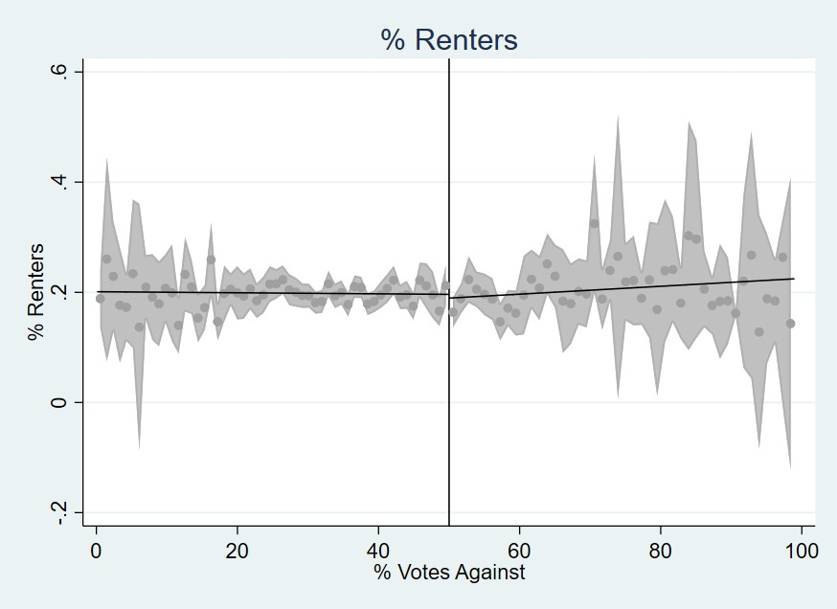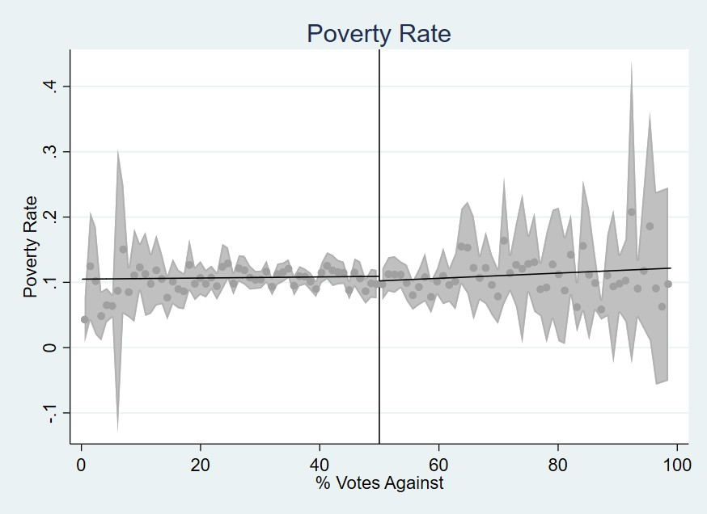
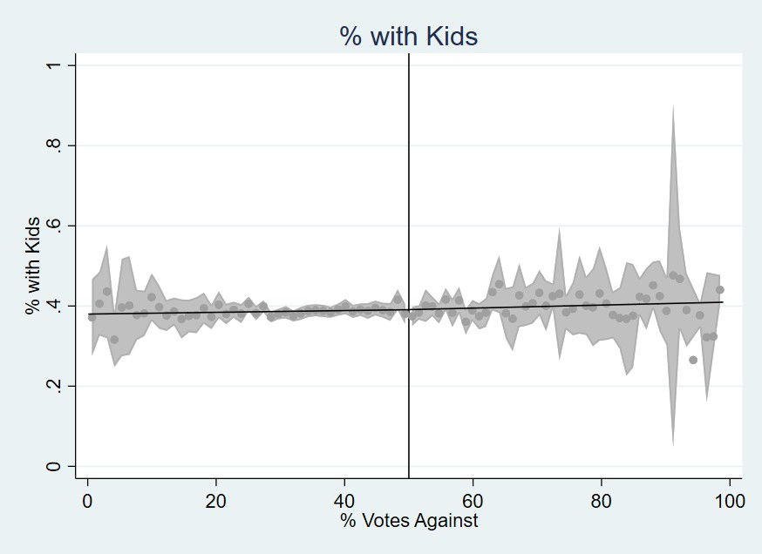
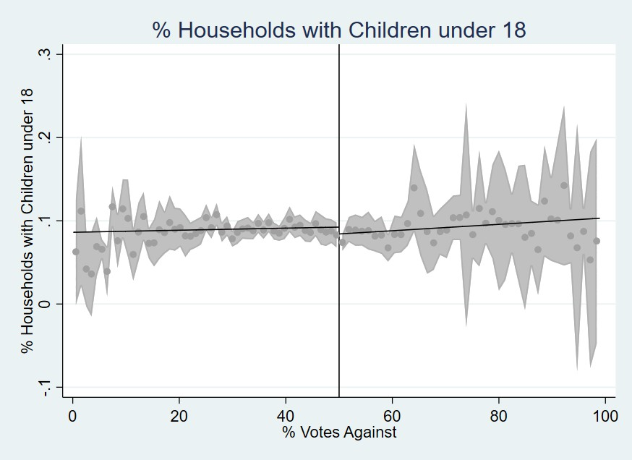
Pct Rent Poverty Rate
Pct With Kids Pct Single Parent Hhld
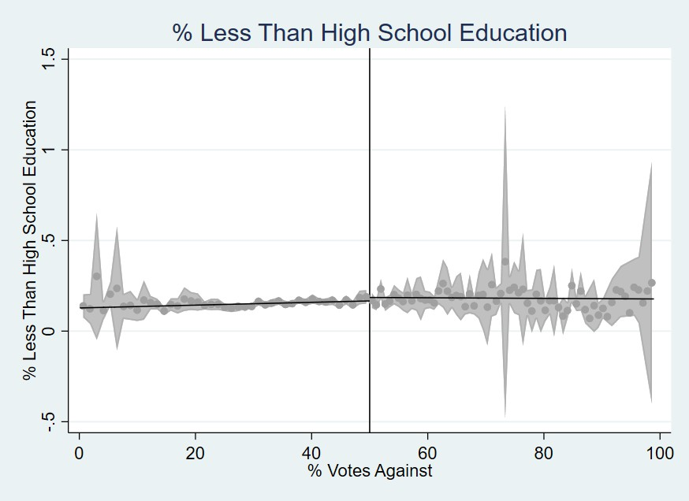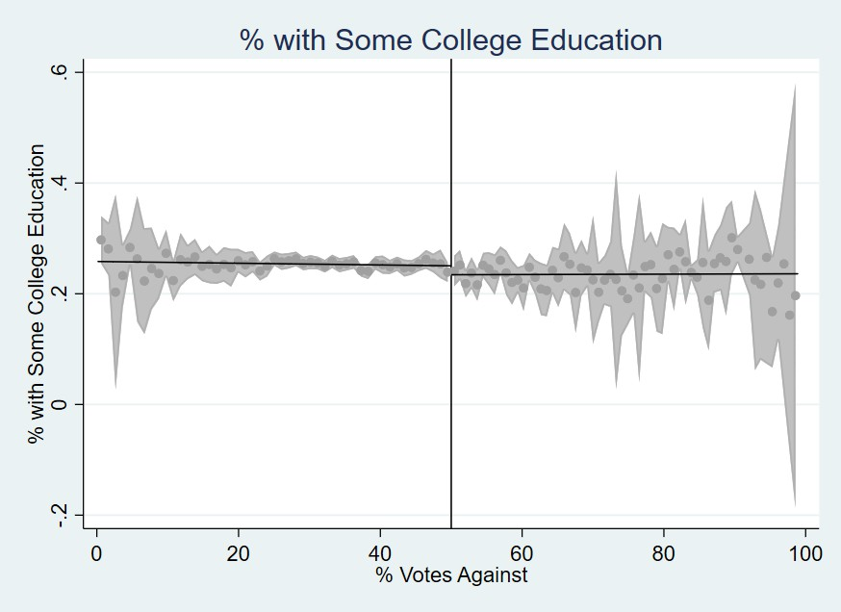
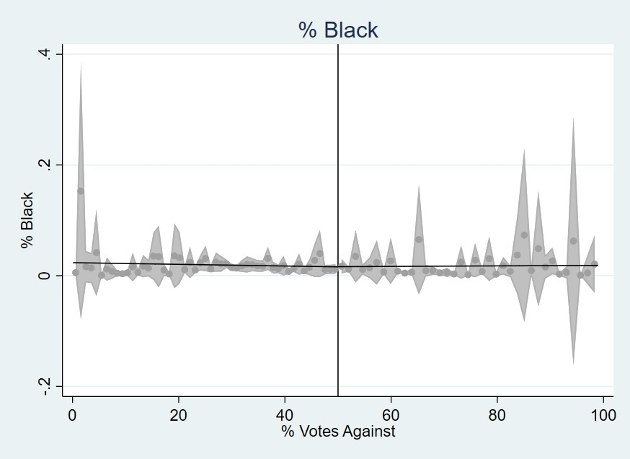
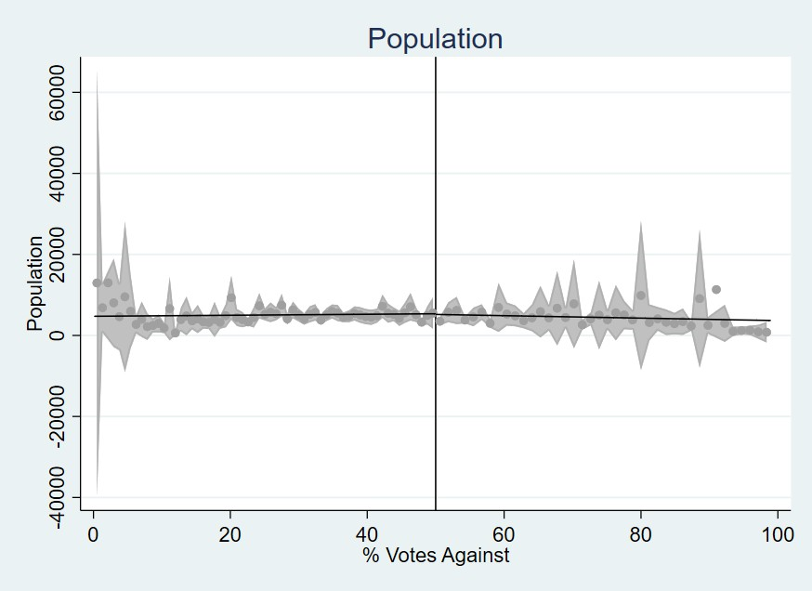
Pct Less than HS Pct Some College
Pct Black Population
Figure 9: Covariate Discontinuity Plots - Part 1

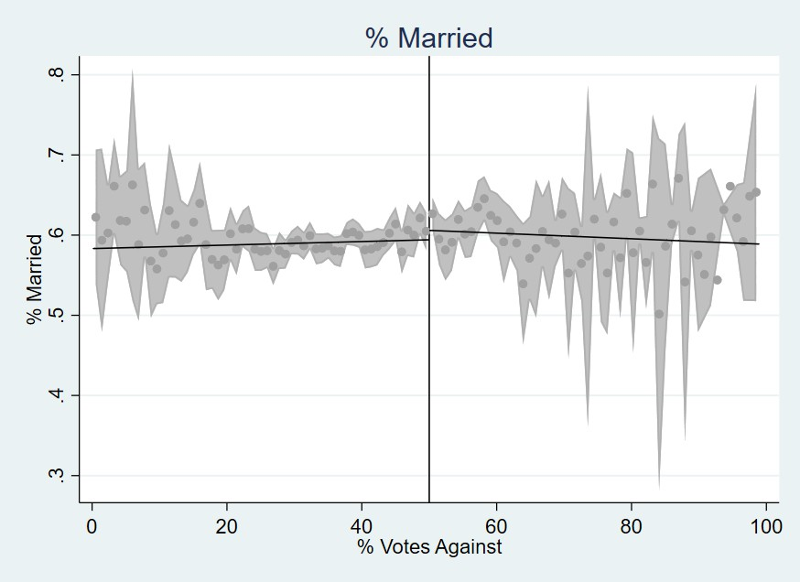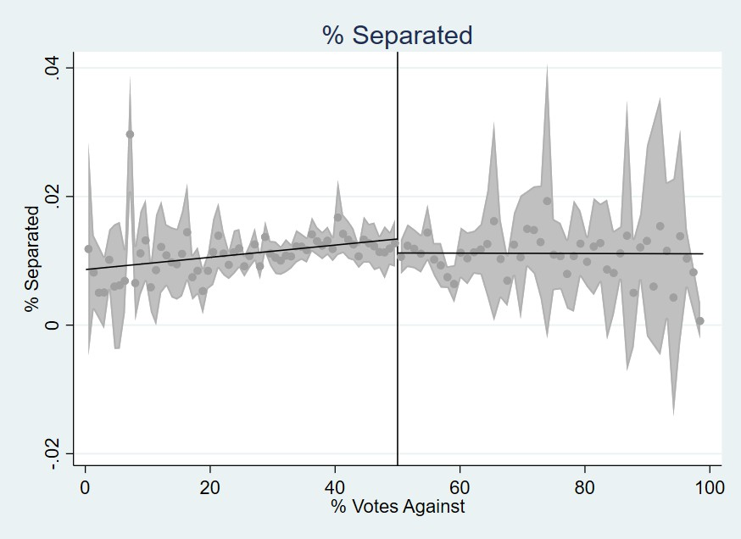
Pct Married Pct Separated
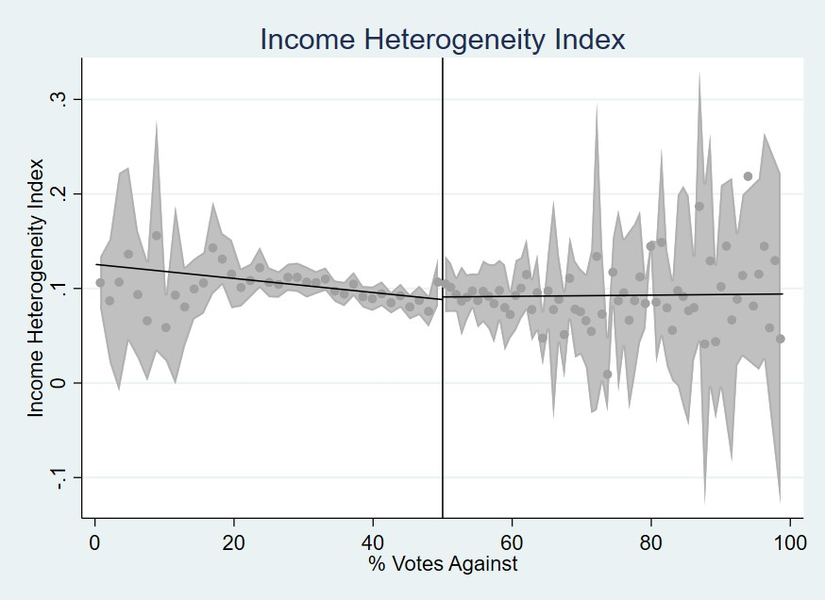
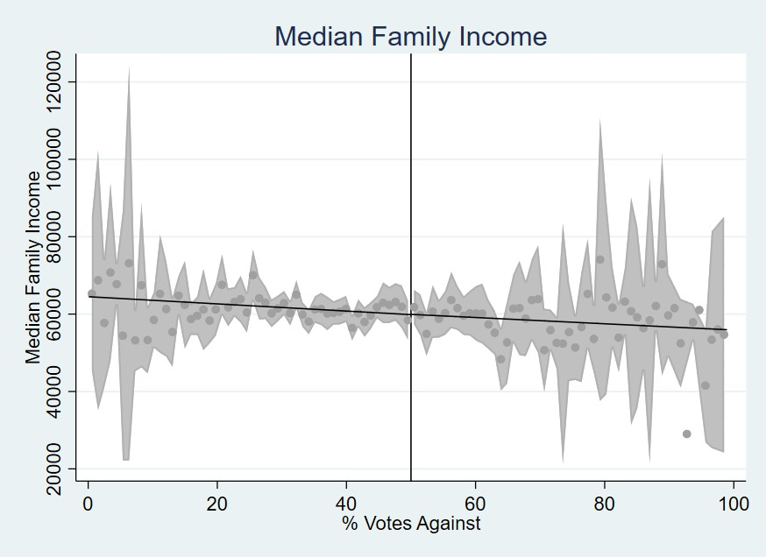
Income Herfindahl Index Median Family Income
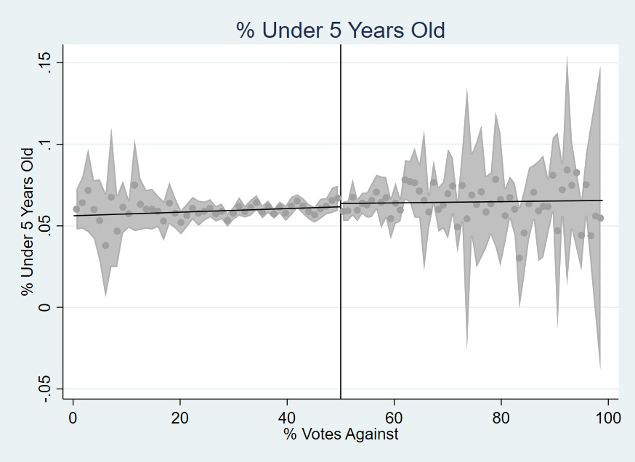
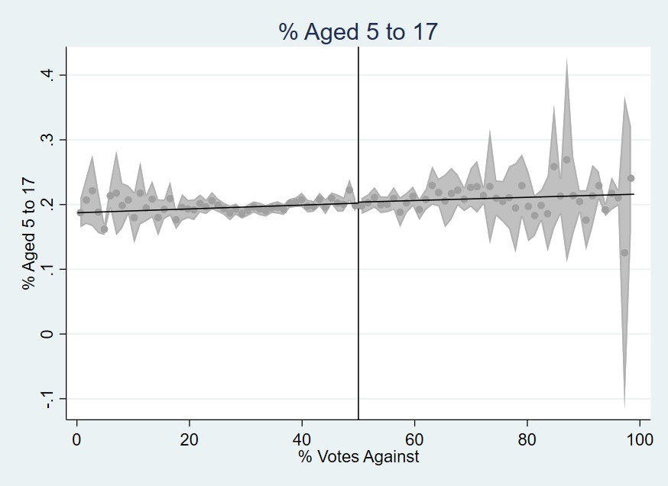
Pct Less than 5 Pct 5 to 17
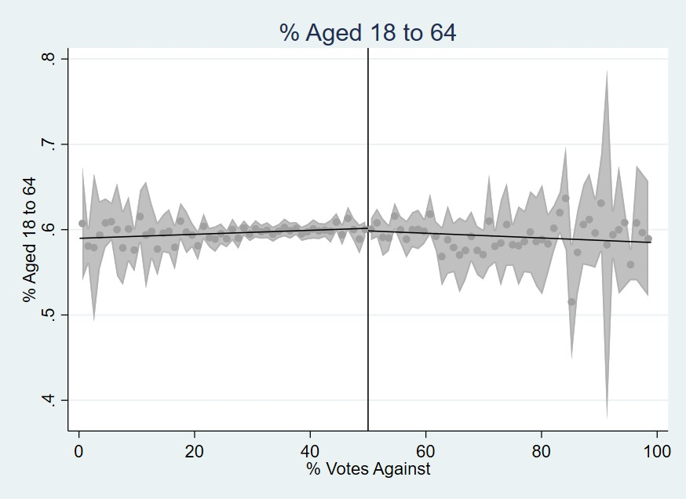
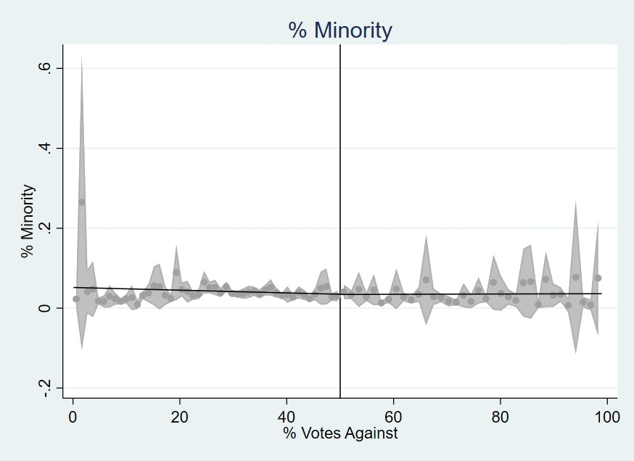

Pct 18 to 64
50 Pct Minority

Figure 10: Covariate Discontinuity Plots - Part 2

